**HO CHI MINH CITY UNIVERSITY OF TECHNOLOGY AND EDUCATION**

**FACULTY OF INTERNATIONAL EDUCATION**

**

**GRADUATION PROJECT**

**DESIGN A SYSTEM TO DISPLAY   
VEHICLE PARAMATER THROUGH OBDII   
ON SMARTPHONES**

**NGUYEN MINH PHU**

**Student ID**: **20145426**

**NGO TAN TRUNG**

**Student ID**: **20145443**

**Major**: **AUTOMOTIVE ENGINEERING**

**Supervisor**: **ASSOC. PROF .DR. DO VAN DUNG**

Ho Chi Minh City, May 2024

**HO CHI MINH CITY UNIVERSITY OF TECHNOLOGY AND EDUCATION**

**FACULTY OF INTERNATIONAL EDUCATION**

**

**GRADUATION PROJECT**

**DESIGN A SYSTEM TO DISPLAY   
VEHICLE PARAMATER THROUGH OBDII   
ON SMARTPHONES**

**NGUYEN MINH PHU**

**Student ID**: **20145426**

**NGO TAN TRUNG**

**Student ID**: **20145443**

**Major**: **AUTOMOTIVE ENGINEERING**

**Supervisor**: **ASSOC. PROF .DR. DO VAN DUNG**

Ho Chi Minh City, May 2024

|  |  |
| --- | --- |
|  | THE SOCIALIST REPUBLIC OF VIETNAM  **Independence – Freedom– Happiness**  -------- |

*Ho Chi Minh City, January 20, 2023*

**GRADUATION PROJECT ASSIGNMENT**

|  |  |
| --- | --- |
| Student name: _________________________ | Student ID: ___________________ |
| Student name: __________________________ | Student ID: ___________________ |
| Student name: __________________________ | Student ID: ___________________ |
| Major: ________________________________ | Class: ________________________ |
| Supervisor: ____________________________ | Phone number: _________________ |
| Date of assignment: _____________________ | Date of submission: _____________ |
| 1. Project title: _________________________________________________________ | |
| 2. Initial materials provided by supervisor: ___________________________________ | |
| 3. Content of the project: _________________________________________________ | |
| 4. Final product: ________________________________________________________ | |
| **CHAIR OF THE PROGRAM**  *(Sign with full name)* | **SUPERVISOR**  *(Sign with full name)* |

|  |  |
| --- | --- |
|  | THE SOCIALIST REPUBLIC OF VIETNAM  **Independence – Freedom– Happiness**  --------  ---- |

**SUPERVISOR’S EVALUATION SHEET**

Student name: ................................................................. Student ID: .................................

Student name: ................................................................. Student ID: .................................

Student name: ................................................................. Student ID: .................................

Major: .....................................................................................................................................

Project title: ............................................................................................................................

................................................................................................................................................ Supervisor: .............................................................................................................................

**EVALUATION**

1. Content of the project:

.................................................................................................................................................

.................................................................................................................................................

.................................................................................................................................................

1. Strengths:

.................................................................................................................................................

.................................................................................................................................................

.................................................................................................................................................

1. Weaknesses:

.................................................................................................................................................

.................................................................................................................................................

.................................................................................................................................................

1. Approval for oral defense? *(Approved or denied)*

.................................................................................................................................................

1. Overall evaluation: (Excellent, Good, Fair, Poor)

.................................................................................................................................................

6. Mark:……………….(*in words*: ........................................................................................)

.................................................................................................................................................

*Ho Chi Minh City, month day, year*

**SUPERVISOR**

*(Sign with full name)*

|  |  |
| --- | --- |
|  | THE SOCIALIST REPUBLIC OF VIETNAM  **Independence – Freedom– Happiness**  -------- |

**PRE-DEFENSE EVALUATION SHEET**

Student name: ................................................................. Student ID: .............................

Student name: ................................................................. Student ID: .............................

Student name: ................................................................. Student ID: .............................

Major: .....................................................................................................................................

Project title: .............................................................................................................................

.................................................................................................................................................

Name of Examiner: .................................................................................................................

**EVALUATION**

1. Content and workload of the project

.................................................................................................................................................

.................................................................................................................................................

.................................................................................................................................................

.................................................................................................................................................

2. Strengths:

.................................................................................................................................................

.................................................................................................................................................

.................................................................................................................................................

3. Weaknesses:

.................................................................................................................................................

.................................................................................................................................................

.................................................................................................................................................

4. Approval for oral defense? *(Approved or denied)*

.................................................................................................................................................

5. Overall evaluation: *(Excellent, Good, Fair, Poor)*

.................................................................................................................................................

6. Mark:……………….(*in words*: .......................................................................................)

*Ho Chi Minh City, month day, year*

**EXAMINER**

*(Sign with full name)*

|  |  |
| --- | --- |
|  | THE SOCIALIST REPUBLIC OF VIETNAM  **Independence – Freedom– Happiness**  -------- |

**EVALUATION SHEET OF  
DEFENSE COMMITTEE MEMBER**

Student name: ................................................................. Student ID: .............................

Student name: ................................................................. Student ID: .............................

Student name: ................................................................. Student ID: .............................

Major: ......................................................................................................................................

Project title: ..............................................................................................................................

..................................................................................................................................................

Name of Defense Committee Member: ...................................................................................................................................................

**EVALUATION**

1. Content and workload of the project

.................................................................................................................................................

.................................................................................................................................................

.................................................................................................................................................

.................................................................................................................................................

2. Strengths:

.................................................................................................................................................

.................................................................................................................................................

.................................................................................................................................................

3. Weaknesses:

.................................................................................................................................................

.................................................................................................................................................

.................................................................................................................................................

4. Overall evaluation: *(Excellent, Good, Fair, Poor)*

................................................................................................................................................. 5. Mark: ………………. (*in words*: .......................................................................................)

*Ho Chi Minh City, month day, year*

**COMMITTEE MEMBER**

*(Sign with full name)*

# **ACKNOWLEDGEMENTS**

I would like to express my deepest gratitude to all those who have contributed to the completion of this project, "DESIGN A SYSTEM TO DISPLAY VEHICLE PARAMATER THROUGH OBDII ON SMARTPHONES".

First and foremost, I extend my heartfelt thanks to Assoc. Prof .Dr. Do Van Dung and PhD. Nguyen Trong Thuc, for their invaluable guidance, support, and encouragement throughout this endeavor. Their expertise and insights have been instrumental in shaping the direction of this project.

I am immensely grateful to the partner of my project team for his unwavering dedication and collaborative spirit. He brought unique skills and perspectives to the table, enriching our discussions and enhancing the quality of our work.

I am indebted to Faculty of Vehicle and Energy Engineering, for providing access to resources and facilities essential for the execution of this project. Their assistance has been crucial in overcoming various challenges along the way.

I would also like to thank my family and friends for their unwavering support and encouragement throughout this journey. Their patience, understanding, and belief in my abilities have been a constant source of motivation.

Thank you to everyone who has played a part, no matter how big or small, in making this project a reality. Your contributions have been truly appreciated.

# **ABSTRACT**

The thesis "DESIGN A SYSTEM TO DISPLAY VEHICLE PARAMATER THROUGH OBDII ON SMARTPHONES" was completed with our efforts and dedication. In this thesis, we have focused on carefully analyzing CAN communication methods on vehicles, especially through simulation of CAN signals. From the results obtained from simulation, we have built an algorithm diagram to decode CAN signals in the most effective way.

Not just stopping at the theoretical level, one of the notable points of the thesis is the process of researching and actually implementing a real product. It is the process of researching, designing, manufacturing, and testing both the hardware and software of the product. We have invested a lot of effort and time to ensure the product operates stably and effectively.

One of our team's proud achievements is the integration of our system into a mobile application. This application has been created by us with the aim of simplifying the process of collecting and transmitting information from our system to the end user.

The results we have achieved from our team's project provide a solid basis for developing applications that monitor vehicle conditions at long distances and send information to the host system. This not only helps users easily check the status of their vehicle, but also helps them feel more secure when they are not around the vehicle. We are proud of our contribution to this field and hope that it will bring practical benefits to the car user community.

**TABLE OF CONTENTS**

**ACKNOWLEDGEMENTS** i

**ABSTRACT** ii

**TABLE OF CONTENTS** iii

**LIST OF ABBREVIATIONS** v

**LIST OF FIGURES** vi

**LIST OF TABLES** viii

**Chapter 1 : INTRODUCTION** 1

**1.1.** **Reason for choosing topic** 1

**1.2.** **The urgency of the subject** 2

**1.3.** **Objective of the study** 2

**1.4.** **Mission of the study** 3

**1.5.** **Scope and Limitation of the study** 3

**1.5.1.** **Scope** 3

**1.5.2.** **Limitation** 3

**1.6.** **Research Methodology** 4

**1.7.** **Thesis implementation plan** 4

**Chapter 2 : LITERATURE REVIEW** 5

**Chapter 3 : THEORETICAL BACKGROUND** 7

**3.1.** **CAN** 7

**3.1.1.** **What is CAN** 7

**3.1.2.** **CAN properties** 8

**3.1.3.** **CAN logic** 10

**3.1.4.** **CAN frame** 12

**3.1.5.** **Benefits** 13

**3.2.** **OBD II** 13

**3.2.1.** **What is OBD II** 13

**3.2.2.** **OBD on car** 14

**3.2.3.** **OBD II frame** 15

**3.3.** **Receive parameter data** 19

**3.3.1.** **Which diagnostic service is used ?** 19

**3.3.2.** **Get and decode the responded frame.** 19

**3.4.** **Receive Diagnotic Trouble Code (DTC)** 20

**3.4.1.** **Which diagnostic Service is used ?** 20

**3.4.2.** **Get and decode the responded frame** 21

**3.5.** **Clear Diagnotic Trouble Code (DTC)** 24

**3.5.1.** **Which diagnotic Service is used ?** 24

**3.5.2.** **Send request to clear DTC** 25

**Chapter 4 : DESIGN SYSTEM** 25

**4.1.** **Simulation** 25

**4.1.1.** **Block diagram and components** 25

**4.1.2.** **Working principle** 27

**4.1.3.** **Result and conclusion** 27

**4.2.** **Design** 28

**4.2.1.** **Block dỉagram and components** 28

**4.2.2.** **Operating principle of the system** 30

**4.2.3.** **Functions of each module in the system** 30

**4.2.3.1.** **Voltage regulator block** 30

**4.2.3.2.** **Bluetooth module block** 30

**4.2.3.3.** **Processing center block** 31

**4.2.3.4.** **Can interface block** 32

**4.2.3.5.** **Display block** 33

**4.2.4.** **Select components** 33

**4.2.4.1.** **Module LM2596 3A** 33

**4.2.4.2.** **Module Arduino Uno R3** 34

**4.2.4.3.** **Module Bluetooth HC – 05** 36

**4.2.4.4.** **Module CAN – BUS Shield** 38

**Chapter 5 :BUILD SYSTEM** 42

**5.1.** **Design hardware** 42

**5.2.** **Design software** 44

**5.2.1.** **Programming phone apps** 44

**5.2.2.** **User interface** 45

**5.2.3.** **Principle of operation of the application** 47

**5.3.** **Algorithm flowchart** 47

**5.3.1.** **Arduino's algorithm flow chart** 47

**5.3.1.1.** **Flow chart of algorithm to get vehicle parameters** 47

**5.3.1.2.** **Flow chart of algorithm to get DTC** 49

**5.3.1.3.** **Flow chart of algorithm to clear DTC** 50

**5.3.2.** **Application’s algorithm flow chart** 51

**Chapter 6 : TESTING ON CAR** 53

**6.1.** **Testing the vehicle's current parameter data** 54

**6.2.** **Testing the vehicle's DTC** 58

**Chapter 7 : CONCLUSION AND RECOMMENDATIONS** 60

**7.1.** **Conclusion** 60

**7.2.** **Limit** 60

**7.3.** **Recommendations** 61

**REFERENCE** 63

**APPENDICES** 64

# **LIST OF ABBREVIATIONS**

ACC: Accessory

ADC: Analog-to-Digital Converter

CAN: Controller Area Network

DTC: Diagnostic Trouble Code

ECU: Electronic Control Unit

EEROM: Electrically Erasable Programmable Read Only Memory

EU: European Union

ID: Identification

ISO: International Organization for Standardization

KB: Kilobyte

Kbps: Kilobits per second

LCD: A liquid-crystal display

LED: A light-emitting diode

mA: Milliamperes

Mbps: Megabits per second

MHZ: Megahertz

OBD: On-Board Diagnostics

PID: Parameter Identification

PWM: Pulse Width Modulation

RPM: Revolutions Per Minute

RX: Receive

SAE: Society of Automotive Engineers

SRAM: Static Random Access Memory

TX: Transmit

US: United States

USB: Universal Serial Bus

VDC: Volts Direct Current

# **LIST OF FIGURES**

Figure 3.1: CAN communication protocol 8

Figure 3.2: CAN logic 11

Figure 3.3: CAN frame 12

Figure 3.4: OBDII port pinout 15

Figure 3.5: OBD2 frame 15

Figure 3.6: Convert HEX code to motor speed 20

Figure 3.7: Single frame 22

Figure 3.8: Multi – frame with pair of data An and Bn 22

Figure 3.9: DTC error code structure read from the engine ECU 23

Figure 4.1: Block diagram 25

Figure 4.2: Components diagram 26

Figure 4.3: Result on serial 27

Figure 4.4: Result on application on phone 28

Figure 4.5: Block diagram 29

Figure 4.6: System diagram 29

Figure 4.7: Module bluetooth HC- 05 31

Figure 4.8: Module Arduino Uno R3 32

Figure 4.9: CAN - BUS Shield 33

Figure 4.10: Connection diagram of module LM2596 3A 34

Figure 4.11: Module Arduino Uno R3 35

Figure 4.12: Module Bluetooth HC – 05 37

Figure 4.13: Communicate Bluetooth module HC-05 with Arduino 38

Figure 4.14: Hardware overview about CAN - BUS Shield 39

Figure 4.15: Pin map of CAN - BUS Shield 41

Figure 5.1: Connect CAN - BUS Shield with Arduino Uno 42

Figure 5.2: Principle diagram 43

Figure 5.3: Finished system 43

Figure 5.4: Design interface 44

Figure 5.5: Set widget parameters 45

Figure 5.6: Select Bluetooth at the first time 46

Figure 5.7: User interface 47

Figure 5.8: Flow chart of algorithm to get vehicle parameters 48

Figure 5.9: Flow chart of algorithm to get DTC 49

Figure 5.10: Flow chart of algorithm to clear DTC 51

Figure 5.11: Application’s algorithm flow chart 52

Figure 6.1: Hardware when plugged into OBD2 port 53

Figure 6.2: Select bluetooth 53

Figure 6.3: Connect with bluetooth 54

Figure 6.4: Data displayed when in STOP mode 54

Figure 6.5: Data displayed when in ACC mode 55

Figure 6.6: Data displayed when the vehicle is in START mode but not moving 56

Figure 6.7: Data displayed when the vehicle moves 57

Figure 6.8: No DTC when the vehicle is in normal condition 58

Figure 6.9: DTC appears when the system has a problem 59

Figure 6.10: DTC data after clearing 59

# **LIST OF TABLES**

Table 3.1: CAN logic 10

Table 3.2: Meaning of USBII port pinout 14

Table 3.3: OBD-II Mode 16

Table 3.4: 4 bytes of data 17

Table 3.5: PID codes 17

Table 3.6: Decode DTC according data A and B 22

Table 3.7: Decoding example according data A and B 23

# **: INTRODUCTION**

* 1. **Reason for choosing topic**

Traffic jams and environmental pollution in large cities have become a serious problem due to the increase in the number of vehicles moving [1]. Car rental and car-sharing services were born as a flexible and environmentally friendly solution, because they help reduce traffic congestion on the streets and reduce environmental pollution through vehicle sharing [2].

Furthermore, this service brings flexibility to users, allowing them to rent cars according to their needs and only pay for the actual time used. This helps save costs compared to owning and maintaining a private car, especially for those who only need to use the car for short periods of time or irregularly.

Along with the development of mobile technology and Internet connection applications, it has created favorable conditions for the development of shared car services. Mobile applications allow users to easily search, book and pay conveniently [3].

The above ideas show that the market for car rental and car sharing services has been growing very strongly domestically and internationally. With the exception of Antarctica, vehicle sharing services are currently available on every continent. Approximately 40% of all car sharing cars worldwide are located in Asia, making it the area with the highest car sharing percentage. Second place goes to Europe, where more than 30% of the world's fleet is based. North America's car-sharing market comes in third.[4]. At that time, car sharing service users need to be able to access information about vehicle status quickly and conveniently to ensure safety and the best experience.

But actually the car rental service still does not meet customer needs as it still lacks some technological improvements applied to satisfy customer requirements. Like a regular car renter, they will not be sure if the car they are currently renting is having any problems to ensure that their trip will go smoothly.

For businesses, managing a large number of vehicles also becomes a problem when they have to ask engineers to use manual inspection methods on each vehicle, which is very time-consuming. Accurately determining the vehicle's condition is extremely necessary. Based on highly rated applications for car rental and car sharing services such as: Zipcar, Turo, Getaround,...

Therefore, our team has chosen this topic to research and develop a solution that allows users or businesses to easily monitor basic vehicle parameters and error codes via the OBD2 port on the vehicle in case the system of the vehicle having problems or damage through the mobile application.

OBDII (On-Board Diagnostics II) is a standard communication port on most modern cars, allowing access to many important vehicle parameters such as speed, fuel level, engine temperature, error codes , and much more information.

Using OBDII to obtain car data is a cost-effective and easy-to-deploy solution compared to developing separate sensors and measurement systems.

* 1. **The urgency of the subject**

As mentioned above, car rental and car sharing services are developing rapidly today, so managing and meeting customer needs effectively and quickly is really necessary in this country. It's time to create a brand right from the beginning to capture the market. It can be seen that this problem is extremely urgent.

That is the premise for our team to create a device that can read the vehicle's condition through technical parameters and then display it on a phone application that can help business owners and customers get more information and vehicle status, thereby having a better experience when using the service.

* 1. **Objective of the study**

This project is carried out with the following purposes:

* Understand the theoretical basis of CAN communication protocols.
* Access the communication system to retrieve data.
* Get the correct value in the desired unit.
* Show many technical parameters of the car on the phone.
* Displays DTC if the vehicle is malfunctioning, damaged and clears DTC.
  1. **Mission of the study**

Thesis tasks include:

* Research and analyze CAN communication protocol.
* Simulate CAN signal through one transmitter and one receiver.
* Build an algorithm diagram to decode the received signal.
* Make a reading device, create an application on the phone, use Bluetooth to transfer data to the phone.
  1. **Scope and Limitation of the study**
     1. **Scope**

The scope may be limited to basic vehicle parameters readily available through the OBD-II standard. More advanced or manufacturer-specific data might require additional research and development.

The study may not delve into complex vehicle diagnostics or repairs, as the focus is primarily on displaying information rather than providing in-depth analysis or troubleshooting.

* + 1. **Limitation**

Projects may be limited by:

* Hardware Compatibility: Not all vehicles are equipped with OBD-II ports, particularly older models. Moreover, variations in OBD-II protocols and data availability across different vehicle manufacturers might require specific adaptations or limit the range of parameters accessible.
* Bluetooth Connectivity: The system relies on a stable Bluetooth connection between the smartphone and the OBD-II adapter. Signal interference, range limitations, or compatibility issues with certain smartphone models might disrupt the data transmission.
* Data Accuracy and Latency: The accuracy and real-time nature of the displayed parameters depend on the quality of the OBD-II adapter and the vehicle's communication protocols. There might be slight delays or discrepancies between the actual values and the data shown on the smartphone.
  1. **Research Methodology**
* Theoretical research: Document analysis and modeling methods to build algorithms to decode OBD signals.
* Experimental research: Use experimental support tools from hardware and software in collecting and evaluating experimental data.
  1. **Thesis implementation plan**

This study include 5 chapters:

* Chapter 1: Present the reason for choosing the topic, object, scope,... of the research.
* Chapter 2: Overview of related research articles.
* Chapter 3: Theoretical basis of CAN, OBD, how to get and decode data.
* Chapter 4: Simulate and design hardware of the system.
* Chapter 5: Assembling hardware, design and program mobile applications.
* Chapter 6: Tested on actual vehicle.
* Chapter 7: Make conclusions and directions for development in the future.

# **: LITERATURE REVIEW**

1. **Title: “Vehicle and Driver Monitoring System Using On-Board and Remote Sensors”.**

* Authors: Andres E. Campos-Ferreira, Jorge de J. Lozoya-Santos, Juan C. Tudon-Martinez, Ricardo A. Ramirez Mendoza, Adriana Vargas-Martínez, Ruben Morales-Menendez, Diego Lozano.
* Abstract: This paper presents an integrated monitoring system that combines on-board vehicle sensors and remote sensors to estimate polluting emissions, fuel consumption, driving style, and driver’s health. The analysis focuses on interactions between these monitored features, emphasizing the influence of the driver on vehicle performance and vice versa. The system was experimentally implemented using a mobile application. Compared to commercial driver and vehicle monitoring systems, this approach uses classical sensor measurements and simple algorithms but provides valuable insights into driver-vehicle interactions.

1. **Title: “Intelligent Autonomous Vehicle Control Using Smartphone”.**

* Authors: K. M. Smruthi, K. N. Yashwanth, M. N. Vijayalakshmi.
* Abstract: This study explores the use of smartphones for intelligent autonomous vehicle control. The integration of smartphones with OBD-II (On-Board Diagnostics) systems allows real-time monitoring of vehicle parameters. By leveraging smartphone sensors and connectivity, researchers have developed applications for vehicle diagnostics, fuel efficiency optimization, and driver behavior analysis.

1. **Title: “IoT-based Smart Vehicle Monitoring System”.**

* Author: S Kumar Reddy Mallidi.
* Abstract: This systematic literature review investigates various systems allowing the tracking of ECU (Engine Control Unit) data on smartphones via OBD-II. Researchers have explored different approaches to collect and analyze vehicle parameters, including fuel consumption, emissions, and driving style. The integration of OBD-II data with smartphone applications enables real-time monitoring and enhances vehicle safety and efficiency.

1. **Title: “Design and Implementation of a Wireless OBD II Fleet Management System”.**

* Authors: Reza Malekian, Ruth Moloisane, Lakshmi Nair, BT(Sunil) Maharaj and Uche A.K. Chude-Okonkwo.
* Abstract: This research focuses on designing a wireless OBD-II (On-Board Diagnostics) fleet management system. OBD-II is a microcontroller designed to interpret OBD-II signaling protocols automatically. The system aims to improve fleet management by providing real-time data on vehicle performance and diagnostics.

1. **Title: “Survey of Smartphone Applications Based on OBD-II for Intelligent Vehicle Systems”.**

* Authors: Gül Fatma Türker, Akif Kutlu.
* Abstract: This survey reviews smartphone applications that utilize OBD-II data for intelligent vehicle systems. Researchers have developed apps for tracking ECU data, diagnosing vehicle issues, and optimizing fuel efficiency. These applications enhance driver awareness and contribute to safer and more efficient driving.

In summary, designing a system to display vehicle parameters through OBD-II on smartphones involves integrating sensor data, developing algorithms, and creating user-friendly applications. These systems contribute to better vehicle performance, driver safety, and environmental impact. Researchers continue to explore innovative ways to leverage OBD-II data for intelligent vehicle control and monitoring.

# **: THEORETICAL BACKGROUND**

6. 1. **CAN**
      1. **What is CAN**

The Controller Area Network (CAN bus) is the nervous system, enabling communication.

In turn, 'nodes' or 'electronic control units' (ECUs) are like parts of the body, interconnected via the CAN bus. Information sensed by one part can be shared with another.

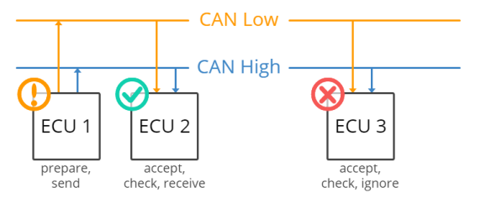

Figure 3.1: CAN communication protocol. [6]

The CAN standard is useful in this situation:

* Each ECU may interact with every other ECU using the may bus technology, eliminating the need for intricate specialized wiring.
* To be more precise, an ECU may use the may bus, which consists of two wires called CAN low and CAN high, to prepare and broadcast information, such as sensor data. Every other ECU connected to the CAN network accepts the broadcasted data.
* After that, each ECU examines the data and determines whether to accept it or reject it.
  + 1. **CAN properties**

Some properties of CAN:

* Wired: In a variety of industrial and automotive settings, CAN facilitates dependable communication over extended distances using physical cabling, usually twisted pair cables. CAN buses, for instance, link different electronic control units (ECUs) in an automobile, including infotainment systems, airbag systems, and engine control modules.
* Serial: Data is sent over the network bit by bit during serial communication in CAN. For real-time applications where timing is crucial, serial communication enables simplified wiring and effective data transfer rates.
* Asynchronous: CAN communication is asynchronous, in contrast to synchronous communication techniques, which depend on a shared clock signal. The CAN bus's independent operation of each node enables flexible, decentralized communication without the constraints of precise timing.
* Broadcast: CAN messages are transmitted to every network node, enabling numerous devices to receive and process the data at the same time. For real-time monitoring and control, a sensor node in an industrial automation system, for instance, can broadcast a status update to every controller attached to it.
* Message-Based Protocol: Data is packed into frames made up of an identifier, a data field, and control bits in the message-based protocol that CAN uses. This message structure offers a defined framework for data exchange, which facilitates effective communication between nodes.
* Message Filtering: Nodes can receive and process messages selectively depending on identifiers or data content thanks to CAN's support for message filtering technologies. An airbag control module in a car, for example, might filter incoming messages in the CAN network to only respond to signals pertaining to accident sensor data.
* Half Duplex: CAN communication operates on a half-duplex basis, allowing nodes to send and receive data at different times but not concurrently. Through the reduction of collisions and the optimization of bandwidth availability, this facilitates the effective use of the communication channel.
* Acknowledgment: To provide dependable message transmission, CAN uses acknowledgment methods. A node notifies the sender of a successful message reception by sending back an acknowledgment (ACK) signal. To maintain data integrity, the sender retries transmission if no acknowledgment is received in a predetermined amount of time.
* CSMA-CA Protocol: "Listening" to the bus before attempting to transmit data is what the Carrier Sense Multiple Access (CSMA) protocol does. A node will wait until the bus becomes idle before attempting to send its own message if it detects that the bus is busy, meaning that another node is already broadcasting. By guaranteeing that only one node communicates at a time, this helps prevent collisions. Collision Resolution: If two or more nodes try to transmit simultaneously, collisions may still happen even with the CSMA mechanism in place. Under CAN, disputes are settled by a priority-based arbitration system. Lower-ID messages have a greater priority than higher-ID messages on the CAN bus. Each message has a unique identifier (ID). When several nodes try to transmit at the same time, the node with the lower ID wins the arbitration procedure and is allowed to send its message first, forcing the other nodes to give up and try again later. Because of its deterministic arbitration mechanism, which guarantees the fastest possible transmission of higher-priority messages, CAN is appropriate for real-time applications.
* Node Failures, Both Temporary and Permanent: CAN is built to gracefully handle node failures, both temporary and permanent. The network can identify and recover from problems brought on by malfunctioning nodes thanks to error detection and handling features like cyclic redundancy check (CRC) and error frames, which guarantee uninterrupted operation.
  + 1. **CAN logic**

Table 3.1: CAN logic

|  |  |  |  |
| --- | --- | --- | --- |
|  | CAN H (Volts) | CAN L (Volts) | Delta V |
| Logic 1 | 2.5 | 2.5 | 0 |
| Logic 0 | 3.5 | 1.5 | 2 |

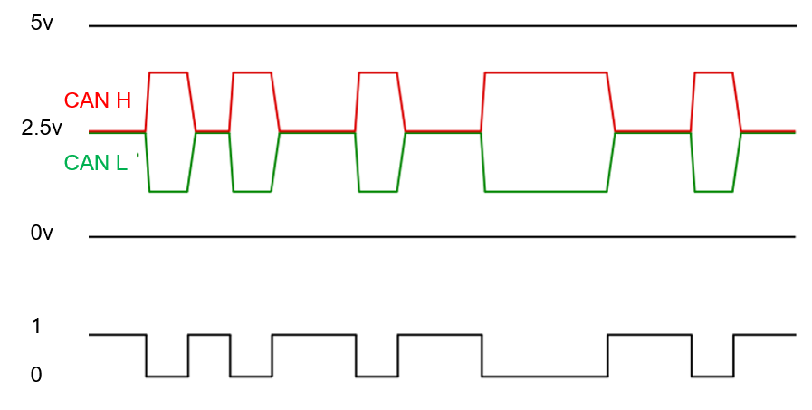

Figure 3.2: CAN logic

CAN_H and CAN_L are the two differential signal lines in the Controller Area Network (CAN) protocol that are used to facilitate communication between bus nodes. The voltage variations between these lines contain the information stored in them.

The logic levels of CAN_H and CAN_L are described as follows in brief:

**State of dominance (Logic 0):**

* CAN_H is at a greater voltage level than CAN_L in the dominant state.
* In the CAN frame, this is equivalent to a logical zero.
* The voltage difference between CAN_H and CAN_L becomes considerable, indicating a dominant bit, when one or more nodes broadcast a dominant signal (0).

**State of retreat (Logic 1):**

* Both CAN_H and CAN_L are at roughly the same voltage level when the system is in the recessive state.
* This is equivalent to a CAN frame logical 1.
* The bus returns to the recessive state and the voltage difference between CAN_H and CAN_L drops, indicating a recessive bit, when no nodes are actively broadcasting a dominant signal.

The CAN protocol's communication logic is based on these two states: dominant (logic 0) and recessive (logic 1). Because CAN_H and CAN_L are differential protocols, they offer integrated error detection and dependable data transfer even in noisy situations. Furthermore, deterministic communication on the CAN bus is ensured by the bus arbitration system, which always grants the dominant state precedence over the recessive state.

* + 1. **CAN frame**

Communication over the CAN bus is done via CAN frames.

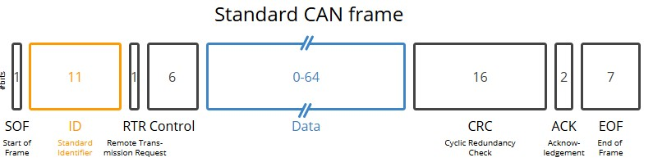

Figure 3.3: CAN frame. [6]

The eight message fields of the CAN bus protocol:

* SOF: A 'dominant 0' indicates to other nodes that a CAN node is ready to communicate.
* ID: The frame identification; smaller values correspond to higher priority.
* RTR: A node's ability to transmit data or request specific data from another node is indicated by the Remote Transmission Request (RTR).
* Control: The Identifier Extension Bit (IDE), or "dominant 0" for 11-bit, is contained in the Control. Additionally, it has a 4-bit Data Length Code (DLC) that indicates the range of data bytes that must be sent, from 0 to 8.
* Data: The payload, or data bytes, in the data comprises may signals that may be retrieved and decoded to obtain information.
* CRC: To guarantee data integrity, utilize the Cyclic Redundancy Check method.
* ACK: The ACK slot signifies whether the node has correctly received and acknowledged the data.
* EOF: This indicates that the CAN frame has ended.

2. 1. 3. **Benefits**

Top 4 advantages of CAN:

* Easy and affordable: Instead of using direct, complicated analogue signal lines for communication, ECUs can interact via a single CAN system, which lowers errors, weight, wiring, and costs.
* Completely centralized In order to communicate with all network ECUs, the CAN bus offers a "one point-of-entry," allowing for configuration, data logging, and central diagnostics.
* Exceptionally strong The technology is resistant to electromagnetic interference and electric disturbances, making it perfect for applications where safety is crucial, like cars.
* ID prioritizes efficient CAN frames such that the highest priority data has quick bus access without interfering with other frames.

## **OBD II**

3. 2. 1. **What is OBD II**

OBD2, to put it briefly, is the internal self-diagnostic system of your car. It's likely that you have already come across OBD2: Has your dashboard's failure indicator light ever been on? That's your car alerting you to a problem. A mechanic will use an OBD2 scanner to identify the problem if you take your car to one. He will do this by attaching the OBD2 reader to the OBD2 16 pin connector that is located next to the steering wheel. This enables him to review and troubleshoot the problem by reading OBD2 codes, also known as Diagnostic Trouble Codes (DTCs).

As previously mentioned, OBD2 communication in the great majority of cars nowadays is based on the CAN bus via ISO 15765. It is helpful to be aware with the other four protocols that served as the foundation for OBD2, though, if you're examining a car that was manufactured before 2008. Additionally take note of the pinouts, which can be used to identify the protocol your automobile might be using.

The five OBD II protocols:

* ISO 15765 (CAN bus): Mandatory in US cars since 2008 and is today used in the vast majority of cars
* ISO14230-4 (KWP2000): The Keyword Protocol 2000 was a common protocol for 2003+ cars in e.g. Asia
* ISO9141-2: Used in EU, Chrysler & Asian cars in 2000-04
* SAE J1850 (VPW): Used mostly in older GM cars
* SAE J1850 (PWM): Used mostly in older Ford cars
  + 1. **OBD on car**

The OBD-II specification provides a standardized hardware interface to the 16-pin (2x8) female J1962 connector. Unlike the OBD-I connector, which is sometimes found in the engine compartment, the OBD-II connector is required to be installed within 2 feet (0.61 m) of the steering wheel (unless the manufacturer imposes use an exemption, in which case the steering wheel remains somewhere within the driver's reach). SAE J1962 defines the pinout of the connector.

Table 3.2: Meaning of USBII port pinout

|  |  |  |  |
| --- | --- | --- | --- |
| **1** | Manufacturer decides. | **9** | Manufacturer decides.. |
| **2** | J1850 Bus (+) | **10** | J1850 Bus (-) |
| **3** | Manufacturer decides.. | **11** | Manufacturer decides.. |
| **4** | Chassis ground | **12** | Manufacturer decides.. |
| **5** | Signal ground | **13** | Manufacturer decides.. |
| **6** | CAN high (ISO 15765-4 and SAE J2284) | **14** | CAN low (ISO 15765-4 and SAE J2284) |
| **7** | K-line (ISO 9142-2) | **15** | L-line (ISO 9142-2) |
| **8** | Manufacturer decides.. | **16** | Source 12V |

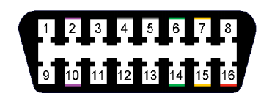

Figure 3.4: OBDII port pinout

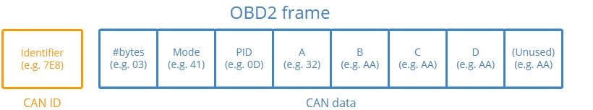

Figure 3.5: OBD2 frame. [6]

3. 2. 3. **OBD II frame**

To get started recording OBD2 data, it is helpful to understand the basics of the raw OBD2 message structure. In simplified terms, an OBD2 message consists of an identifier and data. Further, the data is split in Mode, PID and data bytes (A, B, C, D) as below.

OBD2 message fields explained:

* Identifier: The standard 11-bit identifier for OBD2 messages facilitates the differentiation of "request messages" (ID 7DF) from "response messages" (ID 7E8 to 7EF). Keep in mind that the main engine or ECU will normally react at 7E8.
* Length: This just indicates how many bytes are left in the remaining data (03 to 06). In the case of the Vehicle Speed example, the response is 03 since both 41, 0D, and 32 follow, however the request is 02 because only 01 and 0D follow.
* Mode: This will be in the range of 01-0A for requests. For answers, 4 is used in place of the zero (i.e., 41, 42,..., 4A). The SAE J1979 OBD2 standard lists ten different modes. One usage for Mode 1 is to view Current Data, such as the vehicle's speed, RPM, and other parameters in real time. Additional modes are employed, such as displaying freeze frame data and displaying or clearing saved diagnostic issue codes.
* PID: Standard OBD2 PIDs are listed for each mode; for example, PID 0D in Mode 01 stands for Vehicle Speed. Check out our OBD2 PID overview for the complete list. Every PID has a description, and some of them also provide a conversion formula and min/max values. The speed formula, for example, is only A, which means that the HEX A data byte must be translated to decimal in order to obtain the converted km/h value (i.e., 32 becomes 50 km/h above). For example, the formula is (256*A + B) / 4 for RPM (PID 0C).
* The HEX data bytes A, B, C, and D must be translated to decimal form in order to be utilized in the PID formula computations. Keep in mind that the final data byte (after Dh) is unused.

Table 3.3: OBD-II Mode. [5]

|  |  |
| --- | --- |
| **Mode (hex)** | **Describe** |
| 01 | Represents current data |
| 02 | Displays freeze frame data |
| 03 | Displays stored diagnostic codes |
| 04 | Clear error codes and stored values |
| 05 | Oxygen sensor testing and monitoring results (CAN only) |
| 06 | Other component/system testing and monitoring results (Oxygen sensor testing and monitoring results CAN only) |
| 07 | Displays Pending Error Codes (detected during the current driving process or at the end of the process) |
| 08 | Control the operation of components on ON - BOARD |
| 09 | Request vehicle information |
| 0A | Persistent diagnostic codes (DTCs) (DTCs cleared) |

Table 3.4: 4 bytes of data

|  |  |  |  |  |  |  |  |  |  |  |  |  |  |  |  |
| --- | --- | --- | --- | --- | --- | --- | --- | --- | --- | --- | --- | --- | --- | --- | --- |
| **A** | | | | | | | | **B** | | | | | | | |
| A7 | A6 | A5 | A4 | A3 | A2 | A1 | A0 | B7 | B6 | B5 | B4 | B3 | B2 | B1 | B0 |
| **C** | | | | | | | | **D** | | | | | | | |
| C7 | C6 | C5 | C4 | C3 | C2 | C1 | C0 | D7 | D6 | D5 | D4 | D3 | D2 | D1 | D0 |

Table 3.5: PID codes [5]

|  |  |  |  |  |  |  |  |
| --- | --- | --- | --- | --- | --- | --- | --- |
| PIDs (hex) | PID (Dec) | Number of bytes returned | Description | Min value | Max value | Units | Formula |
| 04 | 4 | 1 | Calculate engine load | 0 | 100 | % |  |
| 05 | 5 | 1 | Engine coolant temperature | -40 | 215 |  | A-40 |
| 0A | 10 | 1 | Fuel pressure (pressure gauge) | 0 | 765 | kPa | 3A |
| 0B | 11 | 1 | Absolute pressure on the intake manifold | 0 | 255 | kPa | A |
| 0C | 12 | 2 | Engine speed | 0 | 16,383.75 | rpm |  |
| 0D | 13 | 1 | Vehicle speed | 0 | 255 | km/h | A |
| 0E | 14 | 1 | Variable valve | -64 | 63.5 | Degree (Before TDC) |  |
| 0F | 15 | 1 | Intake air temperature | -40 | 215 |  |  |
| 10 | 16 | 2 | Intake air mass (MAF) | 0 | 655.35 | grams/sec |  |
| 11 | 17 | 1 | Throttle position | 0 | 100 | % |  |
| 49 | 72 | 1 | Accelerator pedal position D | 0 | 100 | % |  |
| 4A | 73 | 1 | Accelerator pedal position E | 0 | 100 | % |  |
| 4B | 74 | 1 | Accelerator pedal position F | 0 | 100 | % |  |

* 1. **Receive parameter data**
     1. **Which diagnostic service is used ?**

To get the current diagnostic session control parameters, use Diagnostic Service 1 in the Unified Diagnostic Services (UDS) protocol over the Controller Area Network (CAN) protocol.

Service 1's goal is to make it possible for the tester, a diagnostic instrument, to find out the Electronic Control Unit's (ECU) current session control settings in a car. This contains facts on the default session type, communication timing parameters, and other relevant session control information.

* + 1. **Get and decode the responded frame.**

Based on the frame of OBD II in figure 3.5.

* Step 1: Request a response frame about the data you want to select by determining the PID of that data through the table 3.5.
* Step 2: Apply the formula according to the table 3.5 and be sure to use the correct data according to the formula.
* Step 3: Convert the value received from hexadecimal number to the unit you want to display.

Example: to get and decode engine speed

* Step 1: Request data

Request frame: 02 01 0C 00 00 00 00 00

With CAN ID: 0x7DF for request

* Step 2: Wait for respond frame from ECU

We will get the respond frame: 04 41 0C XX YY 00 00 00

With CAN ID: 0x7E8 for respond

* Step 3: Decode this value to engine speed information because its value is Hexadecimal.

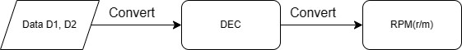

Figure 3.6: Convert HEX code to motor speed

* 1. **Receive Diagnotic Trouble Code (DTC)**
     1. **Which diagnostic Service is used ?**

To get the error code on the car, we have to use 2 diagnostic: service 03 and service 07.

Diagnostic Service 03 (Show stored Diagnostic Trouble Codes) and Diagnostic Service 7 (Show pending Diagnostic Trouble Codes) are both used in the Unified Diagnostic Services (UDS) protocol, which is commonly used in automotive diagnostics over CAN (Controller Area Network) protocol. They serve different purposes in retrieving Diagnostic Trouble Codes (DTCs):

* Diagnostic Service 03 (Read DTC Information):
* Diagnostic trouble codes that are kept in the Electronic Control Unit (ECU) memory can be retrieved using this function.
* It offers details on any malfunctions or problems the ECU has found.
* In addition to additional data like DTC status (active, inactive, pending), and other relevant information, it typically returns information on the DTCs themselves.
* Diagnostic Service 07 (Extended Data Identifier):
* Retrieving DTCs is just one of the many uses for this more flexible service.
* It may retrieve various kinds of diagnostic information based on the parameters that are given.
* In comparison to Service 3, it provides greater flexibility in terms of the data that may be accessed, even if it can also be used to get DTCs.
* To be more precise about the kind of diagnostic data you wish to receive, you might need to provide a few more factors.
  + 1. **Get and decode the responded frame**

Service 03 and Service 07 (no PID required)

The frame of request: 01 03 00 00 00 00 00 00 (Service 03)

The frame of request: 01 07 00 00 00 00 00 00 (Service 07)

With CAN ID: 0x7DF for request

But when there are only 2 DTCs on the vehicle, the response data frame will be in the form of a single frame, and three or more DTCs in the list are reported in multiple frames

* Single frame:

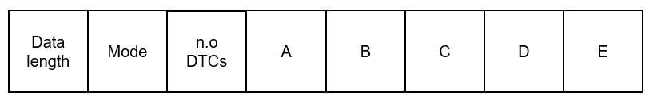

Figure 3.7: Single frame

* Multi – frame

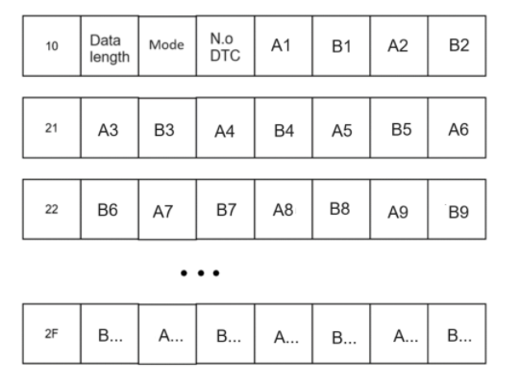

Figure 3.8: Multi – frame with pair of data An and Bn

Table 3.6: Decode DTC according data A and B. [5]

|  |  |
| --- | --- |
| **Bits** | **Definition** |
| A7-A6 | Category  00: **P** – Powertrain  01: **C** – Chassis  10: **B** – Body  11: **U** – Network |
| A5-B0 | Number (within category) |

For each 2 bytes of data, we will have 1 DTC.

An example DTC of "U0158" would be decoded.

Table 3.7: Decoding example according data A and B [5]

|  |  |  |  |  |  |  |  |  |  |  |  |  |  |  |  |  |
| --- | --- | --- | --- | --- | --- | --- | --- | --- | --- | --- | --- | --- | --- | --- | --- | --- |
| Bit | A7 | A6 | A5 | A4 | A3 | A2 | A1 | A0 | B7 | B6 | B5 | B4 | B3 | B2 | B1 | B0 |
| Binary | 1 | 1 | 0 | 0 | 0 | 0 | 0 | 1 | 0 | 1 | 0 | 1 | 1 | 0 | 0 | 0 |
| Hex | C | | | | 1 | | | | 5 | | | | 8 | | | |
| DTC | U | | 0 | | 1 | | | | 5 | | | | 8 | | | |

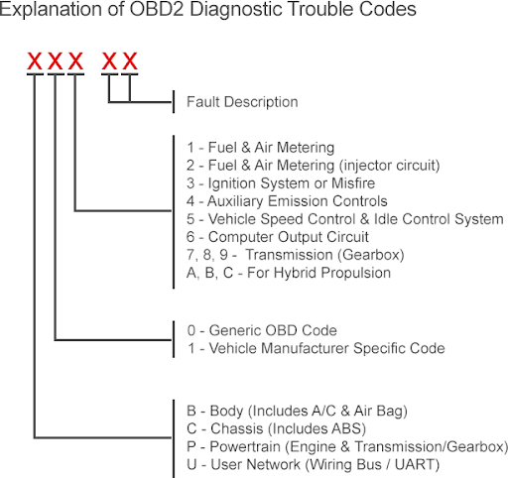

Figure 3.9: DTC error code structure read from the engine ECU

Take code P0302 as an example:

* The first character is a letter indicating the common subsystem that generated the code. Here, (P) represents the powertrain.
* The second character is a zero indicating this is an ISO or SAE code.
* The third numeric character represents the affected subsystem. Here, (3) represents an inoperative ignition system.
* The last 2 digits indicate a code number to identify a specific error in the circuit or component. Here, (02) indicates that the ignition error occurred in cylinder number 2.
  1. **Clear Diagnotic Trouble Code (DTC)**
     1. **Which diagnotic Service is used ?**

Service 04: Clear Diagnostic Trouble Codes and stored values.

Service 04 in the OBD-II standard is used to clear stored Diagnostic Trouble Codes (DTCs) and any related diagnostic data. This service is particularly useful after repairs have been made to the vehicle, as it allows technicians to reset the vehicle's onboard diagnostic system and turn off the malfunction indicator lamp (MIL), commonly known as the check engine light.

**Functionality:**

When a diagnostic tool sends a Service 04 request to the vehicle's onboard computer (ECU), the ECU responds by:

* Clearing Stored DTCs: All current DTCs stored in the ECU's memory are erased. This includes both confirmed and pending codes.
* Resetting Diagnostic Data: Any diagnostic information related to the conditions that triggered the DTCs, such as freeze frame data, is also cleared. Freeze frame data provides a snapshot of the vehicle's operating conditions at the time a fault was detected.
* Turning Off the MIL: The malfunction indicator lamp (MIL) or check engine light is turned off, indicating that there are no current faults detected by the vehicle's diagnostic system.
  + 1. **Send request to clear DTC**

Service 04: Clear Diagnostic Trouble Codes and stored values (no PID required).

The frame of request: 01 04 00 00 00 00 00 00 (Service 04).

With CAN ID: 0x7DF for request.

# **: DESIGN SYSTEM**

4. 1. **Simulation** 
      1. **Block diagram and components**

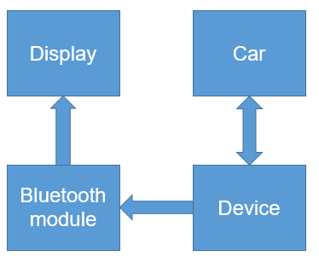

Figure 4.1: Block diagram

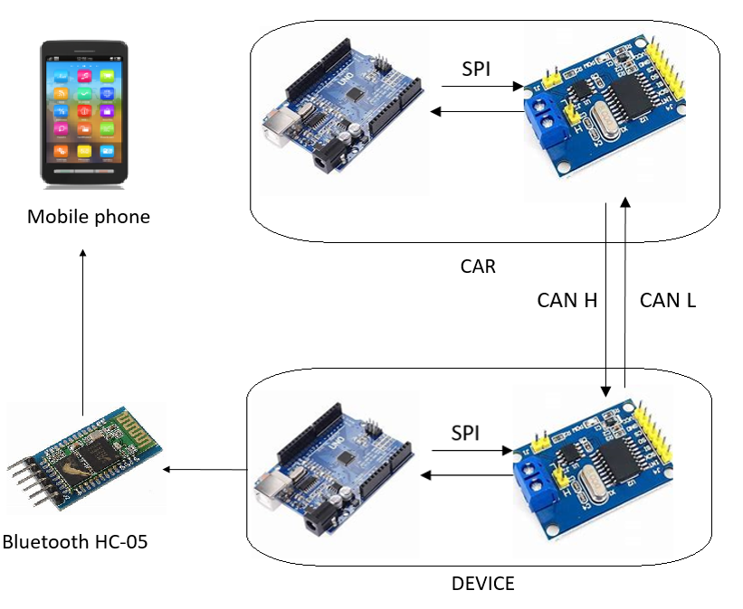

Figure 4.2: Components diagram

Roles of these components :

* Arduino still retains the role of a main processor. The main functions of Arduino in this case include:
* Controlling communication with the MCP2515 module: Arduino will send and receive communication commands via the SPI interface (Serial Peripheral Interface) to perform data transmission and reception with the MCP2515.
* Data processing: Arduino can process data received from the CAN network or data generated by the Arduino program to send over the CAN network.
* Control other peripherals: Arduino can use data from the CAN network to control other peripherals, or conversely, use sensors or other peripherals to generate data to send via CAN network.
* Module MCP2515 is a CAN controller microchip, it helps Arduino Uno R3 to be able to communicate via CAN (Controller Area Network) protocol. Acting as an interface between the Arduino microprocessor and the CAN network, the MCP2515 allows the Arduino to transmit and receive data according to the CAN standard, popular in applications such as cars, industrial equipment, control systems, etc. . This opens up the possibility of connecting the Arduino to other devices in a CAN network andcommunicating with them.
* Bluetooth HC-05: Data interchange in both directions is made possible by the HC-05 Bluetooth module, which enables wireless connectivity between the Arduino and the smartphone. It serves as a link between the Bluetooth interface of the mobile phone and the Arduino microcontroller.
  + 1. **Working principle**

Based on the properties of CAN communication protocol, there are block diagrams and component diagrams that operate based on the properties of CAN. That model works based on this below steps:

* First, device will first send a data frame to send the data request to the ECU.
* Second, The in-car ECU will check the received data frame to see what information the data frame requires via OBD PIDs and mode. Based on that data, the ECU will send back a response data to device.
* Third, The device will send that signal to an application on the phone through the HC-05 bluetooth module.

* + 1. 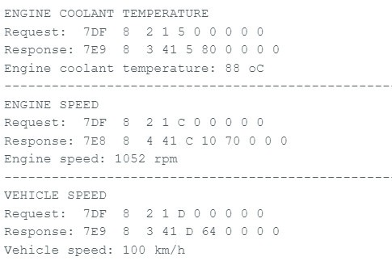**Result and conclusion**

Figure 4.3: Result on serial

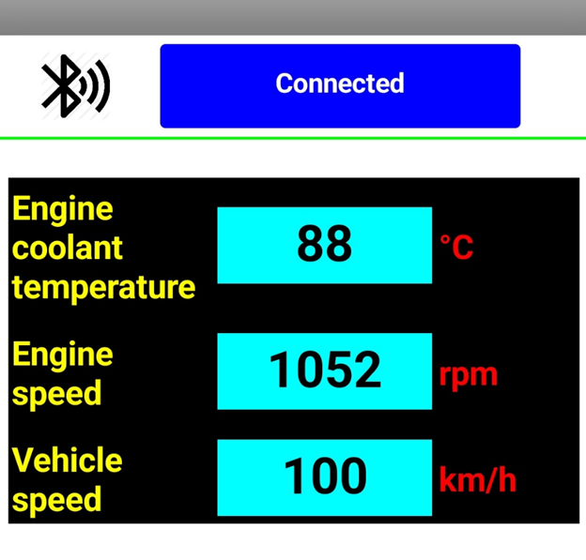

Figure 4.4: Result on application on phone

After this simulation, can understand the structure of CAN messages, including identifiers, data length codes (DLC), and the actual data payload. This helps in designing and interpreting messages in real-world CAN systems. My team may confirm that the data transmitted from one node is accurately received by the other node, hence confirming the integrity of the data transmission. This guarantees error-free, dependable data transmission.

* 1. **Design** 
     1. **Block dỉagram and components**

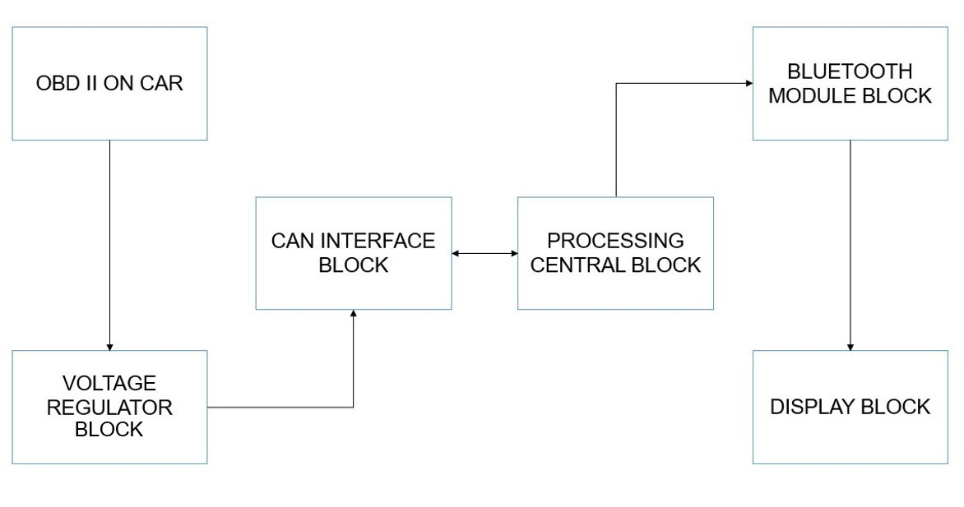

Figure 4.5: Block diagram

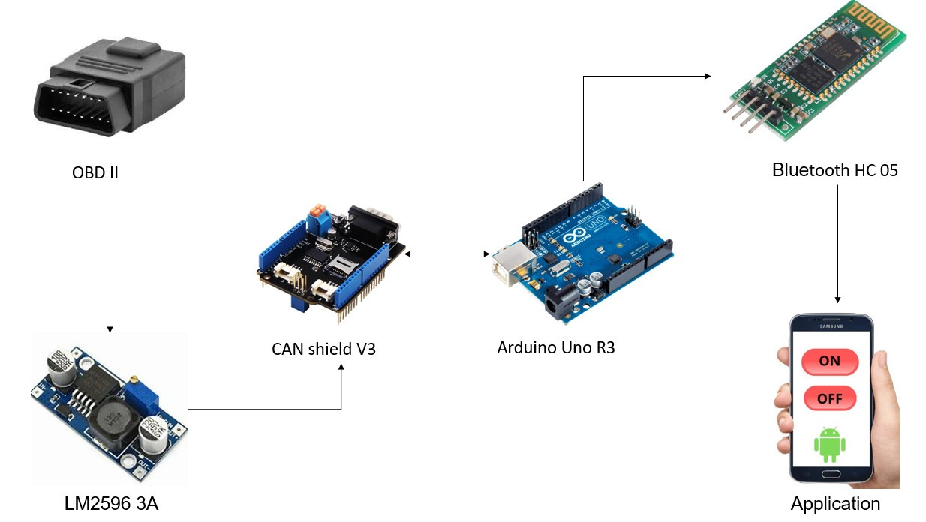

Figure 4.6: System diagram

In order to create devices that can read data via OBD II and display it on a mobile device, the following parts would be required:

* Lower the source voltage (LM2596 3A): Provide appropriate power to the system
* Reader for OBD II (CAN shield ): This gadget obtains diagnostic data by connecting via a cable to the OBD II port in the car.
* Microcontroller (Arduino UNO R3): It prepares the data for transmission by processing it after receiving it from the OBD II scanner.
* The Bluetooth module (Bluetooth HC – 05) facilitates wireless connection between the mobile phone and the microcontroller.
* Mobile Application: In order for the phone to receive data from the microcontroller over Bluetooth and present it in an interface that is easy to use, an application must be created.
* Power Supply: In order to provide the device power, a power source is needed. This can be a power adaptor or a battery.

Connecting the OBD II reader to the car's OBD II port would enable the device to function. The vehicle's onboard computer provides the reader with information such as engine RPM, speed, fuel consumption, and diagnostic issue codes. After processing the data, the microcontroller uses Bluetooth to deliver it wirelessly to the mobile device. The data is received by the mobile application, which then presents it to the user in a legible style and offers insights on the health and performance of the car.

* + 1. **Operating principle of the system**

The First, launch the Android software "Virtuino 6". If accessing the software for the first time, select the upper left corner to select the Bluetooth you want to connect to. Next time you do not need to select Bluetooth unless you want to change the bluetooth selection. Then select the upper right corner then select "Connect" to connect to bluetooth. After connecting, the vehicle's parameters will be displayed on the software. In the option selection section, after selecting the data will be displayed in the box below.

* + 1. **Functions of each module in the system**
       1. **Voltage regulator block**

The LM2596 3A is a monolithic integrated circuit (IC) designed to function as a step-down voltage regulator, also known as a buck converter. Its primary function is to efficiently reduce a higher input voltage to a lower desired output voltage.

* + - 1. **Bluetooth module block**

On the market today, there are many Bluetooth modules that support microcontrollers communicating with other devices via Bluetooth connections. Some commonly used Bluetooth modules in practice include: HC-05 Bluetooth module, HC-06 Bluetooth module. However, the HC-05 Bluetooth module is the preferred choice for this project because: it is cheaper than other modules, the operating speed is suitable for data transmission to control devices, it is easy to buy in the Vietnamese market, and it is used by many people and is highly rated as stable.

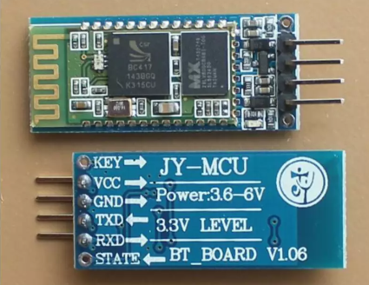

Figure 4.7: Module bluetooth HC- 05

* + - 1. **Processing center block**

Arduino UNO R3 uses the ATmega328 microcontroller. This brain can handle simple tasks such as controlling blinking LEDs, processing signals for remote control cars, controlling stepper motors, controlling servo motors, making a temperature and humidity sensor station and displaying it on an LCD screen, or other applications.

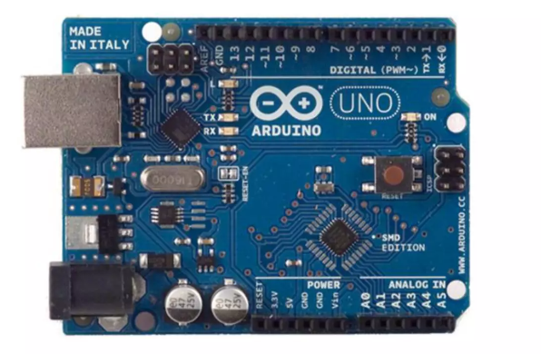

Figure 4.8: Module Arduino Uno R3

* + - 1. **Can interface block**

CAN - BUS Shield is an expansion module designed to connect to Arduino boards and enable communication through the Controller Area Network (CAN) protocol. The CAN Shield allows Arduino to communicate with other devices on the CAN network such as sensors, motor controllers, or other CAN communication modules.

This module can operate at data transmission speeds of up to 1Mbps and supports various data transmission formats such as Standard CAN (11-bit identifier) and Extended CAN (29-bit identifier). With the CAN Shield v1.2, users can easily implement projects related to controlling and monitoring devices on the CAN network in a flexible and efficient manner.

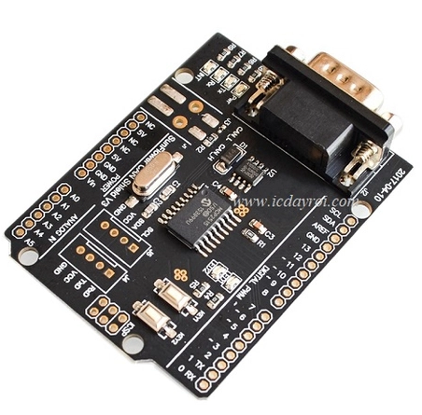

Figure 4.9: CAN - BUS Shield

* + - 1. **Display block**

All phones running the Android operating system can install the Virtuino 6 application, an application written on MIT App Inventor that creates an intuitive, easy-to-use interface to monitor vehicle parameters and status.

* + 1. **Select components**
       1. **Module LM2596 3A**

1. **Specifications**

+ Input voltage: From 3V to 30V.

+ Output voltage: Adjustable between 1.5V and 30V.

+ Maximum response current is 3A.

+ Efficiency: 92%

+ Power: 15W

+ Dimensions: 45 (length) * 20 (width) * 14 (height) mm

1. **Input/ Output**

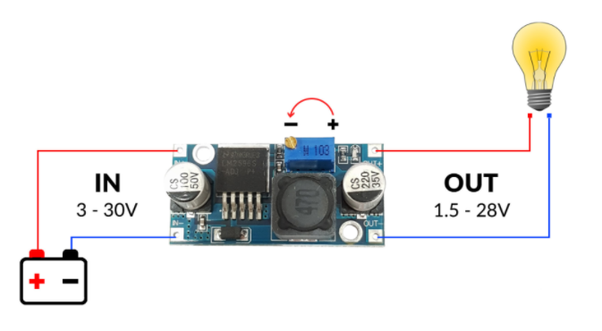

Figure 4.10: Connection diagram of module LM2596 3A

The module has 2 inputs IN, OUT, 1 variable resistor to adjust the output voltage. When supplying power to the input (IN), the user turns the variable resistor and uses VOM to measure the voltage level at the output (OUT) to reach the desired voltage level. Input voltage from 4-35V, output voltage from 1.25-30V, Max current 3A.

* + - 1. **Module Arduino Uno R3**

1. **Specifications**

**+** Microcontroller: ATmega 328 8-bit

+ Operating voltage: 5 VDC (supplied via USB port only)

+ Operating frequency: 16 MHz

+ Current consumption: 30 mA

+ Recommended input voltage: 7-12 VDC

+ Limit input voltage: 6-20 VDC

+ Number of digital I/O pins: 14 (6 hardware PWM pins)

+ Number of analog pins: 6 (10 bit resolution)

+ Maximum current per I/O pin: 30 mA

+ Maximum output current (5V): 500mA

+ Maximum output current (3.3V): 50mA

+ Flash memory: 32KB with 0.5KB used for bootloader

+ SRAM: 2KB

+ EEROM: 1KB

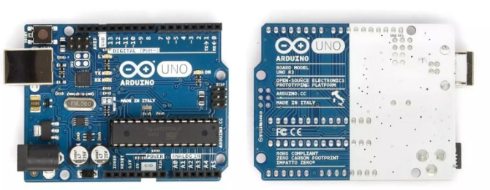

Figure 4.11: Module Arduino Uno R3

1. **Memory**
   * 32KB for flash memory: The programming instructions will be stored in the flash memory of the microcontroller. Typically, a few KB of this will be used for the bootloader.
   * 2KB for SRAM (Static Random Access Memory): The values of variables declared during programming will be stored here. The more variables declared, the more RAM memory is used. When power is lost, data in SRAM will be lost.
   * **1KB for EEPROM (Electrically Erasable Programmable Read Only Memory):** this is like a small hard drive - where can store and retrieve data without having to worry about losing it when the power goes out, unlike data on SRAM.
   * **Input/output ports:**

* The Arduino UNO has 14 digital pins that can be used to read or output signals.
* They only have two voltage levels: 0V and 5V with a maximum input/output current per pin of 40mA.
* Each pin has pull-up resistors built into the ATmega328 microcontroller (these resistors are not connected by default).

1. **Input/Output**

* 2 Serial pins: 0 (RX) and 1 (TX): used to send (transmit – TX) and receive (receive –RX) TTL Serial data. Arduino Uno can communicate with other devices through these two pins. The commonly seen bluetooth connection is basically a wireless Serial connection. If you do not need Serial communication, you should not use these two pins if not necessary
* PWM pin (~): 3, 5, 6, 9, 10, and 11: allows you to output PWM pulses with 8 bit resolution (values ​​from 0 → 28-1 corresponding to 0V → 5V) using the function analogWrite(). Simply put, you can adjust the output voltage at this pin from 0V to 5V instead of just being fixed at 0V and 5V like other pins.
* SPI communication pin: 10 (SS), 11 (MOSI), 12 (MISO), 13 (SCK). In addition to normal functions, these 4 pins are also used to transmit data using the SPI protocol with other devices.
* LED 13: on Arduino UNO there is 1 orange LED (symbol L). When pressing the Reset button, this light flash to signal. It is connected to pin 13. When this pin is used by the user, the LED will light up.
* Arduino UNO has 6 analog pins (A0 - A5) providing 10 bit signal resolution (0 → 210-1) to read voltage values ​​in the range 0V → 5V. With the AREF pin on the board, you can input a reference voltage when using the analog pins. That is, if supply a voltage of 2.5V to this pin, the analog pins to measure the voltage in the range from 0V → 2.5V with a resolution of still 10 bit. In particular, Arduino UNO has 2 pins A4 (SDA) and A5 (SCL) that support I2C/TWI communication with other devices.
  + - 1. **Module Bluetooth HC – 05**

Bluetooth is a wireless communication standard for exchanging data over shortdistances. This communication standard uses shortwave radio (UHF radio) in the ISM frequency range (2.4 to 2.485 GHz). The transmission distance of this module is about 15m.

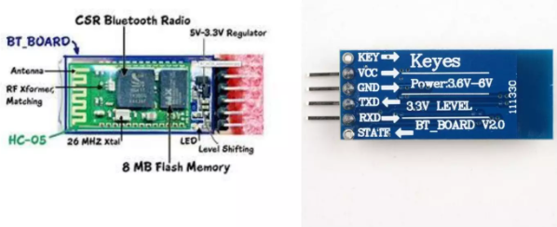

Figure 4.12: Module Bluetooth HC – 05

1. **Specifications**

* Bluetooth protocal: Bluetooth v2.0
* Frequency: 2.4GHz ISM band
* Asynchronous: 2.1 Mbps (Max) / 160kbps
* Synchronous: 1 Mbps / 1Mbps
* Speed: 9600 baud (default)
* Security: Authentication and encryption
* Communication: Bluetooth serial port
* Operating power: +3.3VDC 30mA (Supports 5.0V IC)
* Working temperature: -20 ~ +75 Degree Celsius
* Dimensions: 28mm x 15mm x 2.35mm
* Passkey: 1234
* Device Name: HC – 05

1. **Pinout**

* **KEY**: This pin is used to select between AT Mode or Data Mode operation.
* **VCC**: This pin can be powered from 3.6V to 6V. Inside the module, there is a voltage regulator IC that converts it to 3.3V and supplies it to the BC417 IC.
* **GND**: Connected to the power supply ground.
* **TXD, RND**: These are the two UART pins for communication. The module operates at a logic level of 3.3V.
* **STATE**: Only needs to be left floating, and no attention needs to be paid to this pin.

1. **Setup Description**

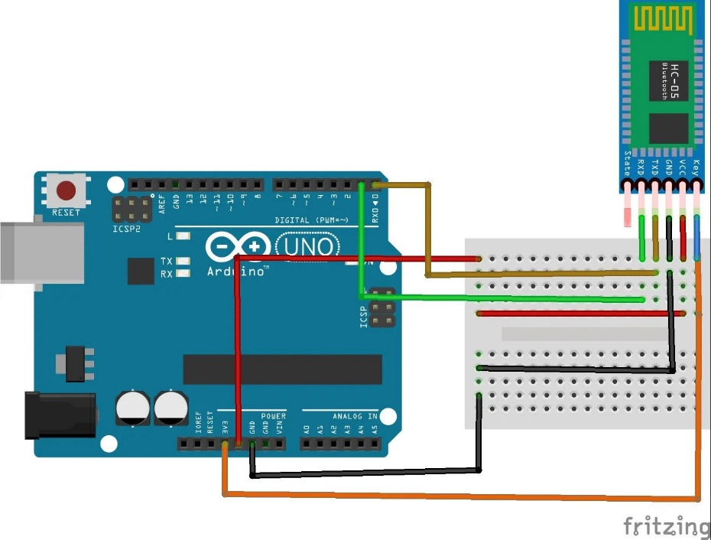

Figure 4.13: Communicate Bluetooth module HC-05 with Arduino

* Connect the TX and RX pins of bluetooth HC - 05 respectively to the RX (0) and TX (1) pins of Ardruno.

**Note**: Connect after loading the program if TX(1) and RX(0) pins are selected. If you choose another pairs of pin, there is no need.

* Connect VCC and GND of bluetooth HC – 05 to VCC and GND of Ardruno.
  + - 1. **Module CAN – BUS Shield**

CAN-BUS is widely used in industrial settings due to its ability to cover long distances, moderate communication speeds, and high reliability. It is frequently employed in modern machine tools, including automotive diagnostic systems.

The CAN-BUS Shield utilizes the MCP2515 CAN Bus controller with SPI interface and MCP2551 CAN transceiver to equip Arduino with CAN-BUS capability. This combination enables Arduino to communicate seamlessly with devices on the CAN network, facilitating integration into various industrial applications.

1. **Features**

* Implements CAN V2.0B speed up to 1 Mb/s.
* SPI Interface speed up to 10 MHz.
* Standard (11 bit) and extended (29 bit) data and remote frames.
* Two receive buffers with prioritized message storage.
* Industrial standard DB-9 connector.
* LED indicators.

1. **Hardware overview**

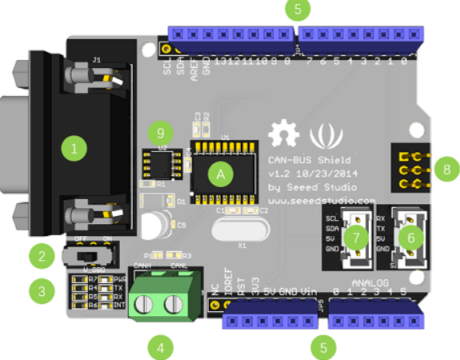

Figure 4.14: Hardware overview about CAN - BUS Shield

1. DB9 Interface - to connect to OBDII Interface via a DBG-OBD Cable.
2. V_OBD - It gets power from OBDII Interface (from DB9)
3. Led Indicator:

* PWR: power
* TX: blink when the data is sending
* RX: blink when there's data receiving
* INT: data interrupt

1. Terminal - CAN_H and CAN_L
2. Arduino UNO pin out
3. Serial Grove connector
4. I2C Grove connector
5. ICSP pins
6. IC - MCP2551, a high-speed CAN transceiver
7. IC - MCP2515, stand-alone CAN controller with SPI interface
8. **Pin map**

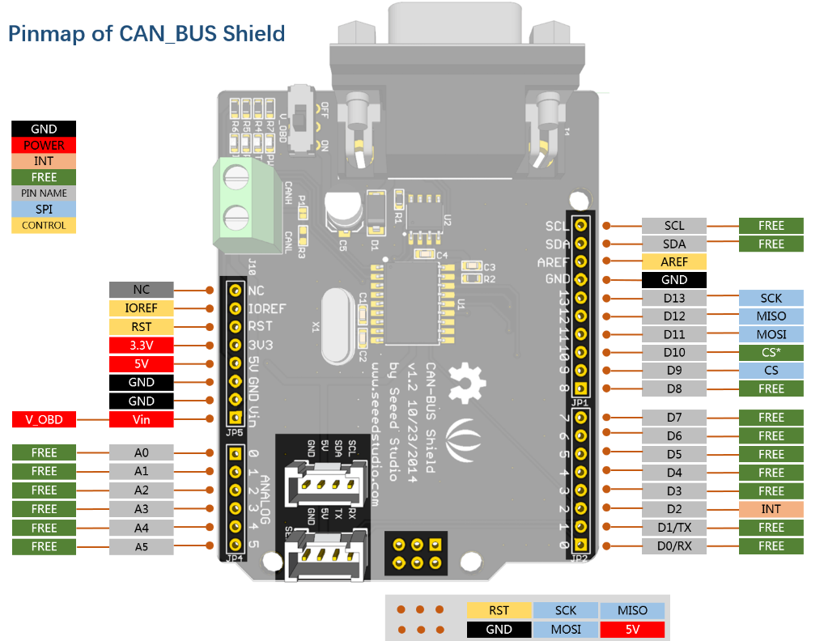

Figure 4.15: Pin map of CAN - BUS Shield

# **:BUILD SYSTEM**

2. 1. **Design hardware**

With the project " DESIGN A SYSTEM TO DISPLAY VEHICLE PARAMATER THROUGH OBDII ON SMARTPHONES ", the hardware design of the system circuit is divided into 5 basic blocks.

* Voltage regulator block
* Bluetooth module block
* Processing center block
* Can interface block
* Display block

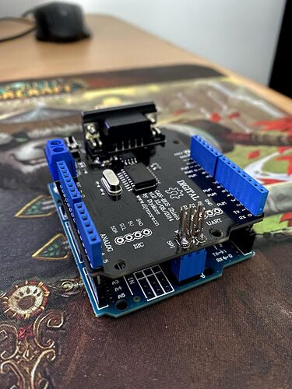

Figure 5.1: Connect CAN - BUS Shield with Arduino Uno

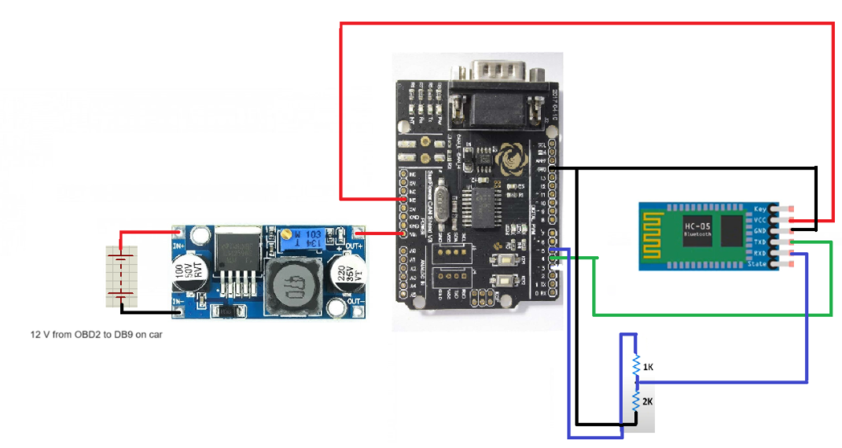

Figure 5.2: Principle diagram

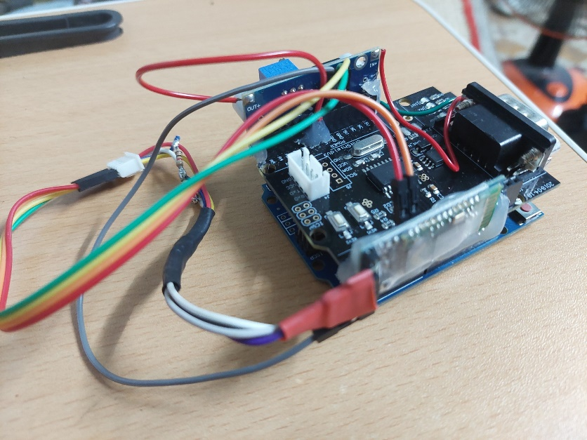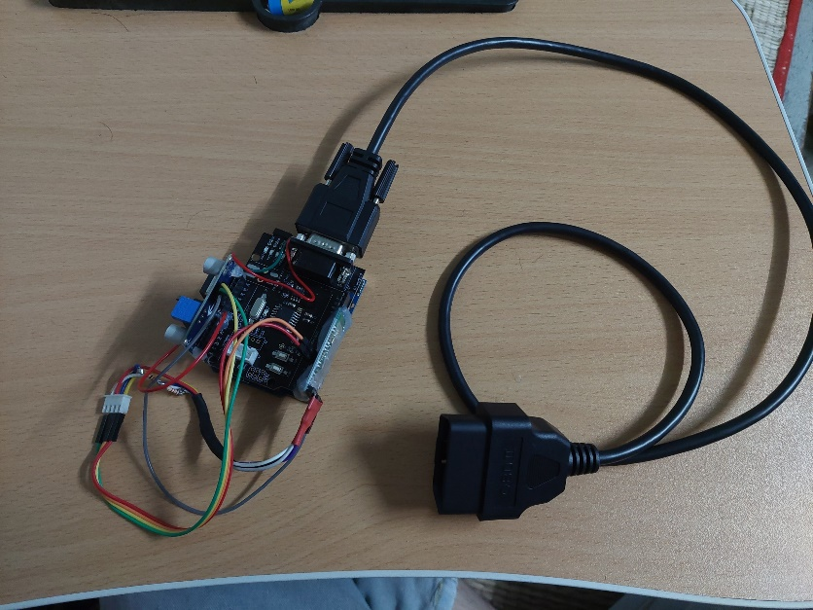

Figure 5.3: Finished system

* 1. **Design software**
     1. **Programming phone apps**

To display the processing results and adjust the setting parameters, we have programmed the installation App into the phone based on “Virtuino 6”. The App is designed directly by the application name and programmed through the "Arduino IDE" platform. The application has built-in clocks and buttons that are very suitable for the design of our project.

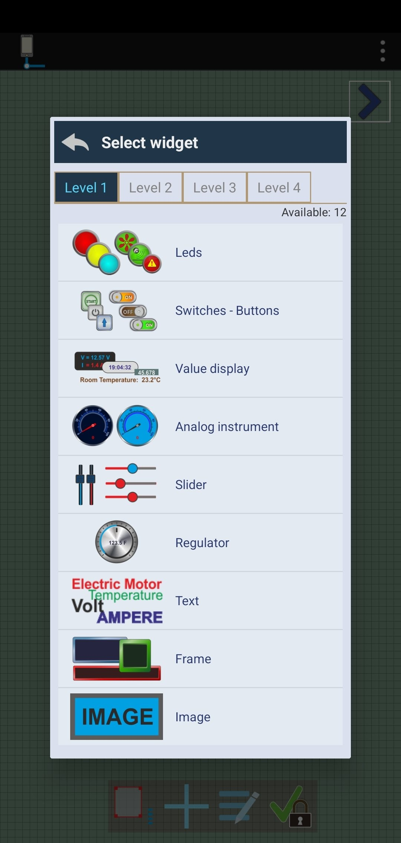

Figure 5.4: Design interface

After designing the user interface, we choose the parameters of each widget:server, memory,... to facilitate programming and easy-to-see design.

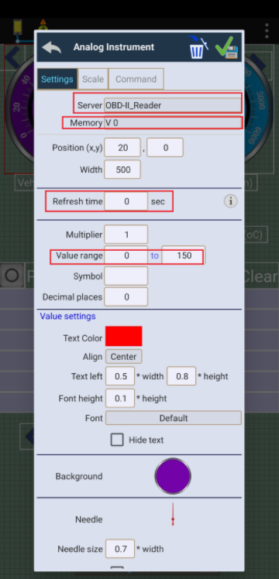

Figure 5.5: Set widget parameters

* + 1. **User interface**

After programming and compiling, running the application will display the user interface, which consists of the following areas: Current vehicle data display area (Area 1), Function selection area (Area 2), Corresponding function data display area (Area 3).

**Note:** select bluetooth (required only once during the initial app setup).

* Current vehicle data display area (Area 1): After sending request data, you will receive response data with vehicle parameters. That data will be processed and sent to bluetooth HC - 05 to send to the application. The application receives data and displays them in this area.
* Function selection area (Area 2): Users select the function they want in this area. Data will be sent from the application to Arduino.
* Corresponding function data display area (Area 3): After receiving a request from the user, the system will process the request and send back data consistent with the user's selection.

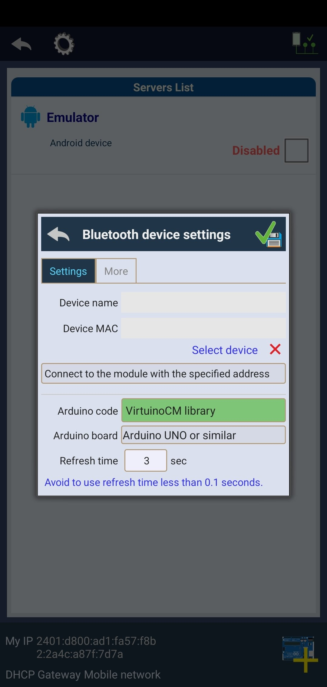

Figure 5.6: Select Bluetooth at the first time

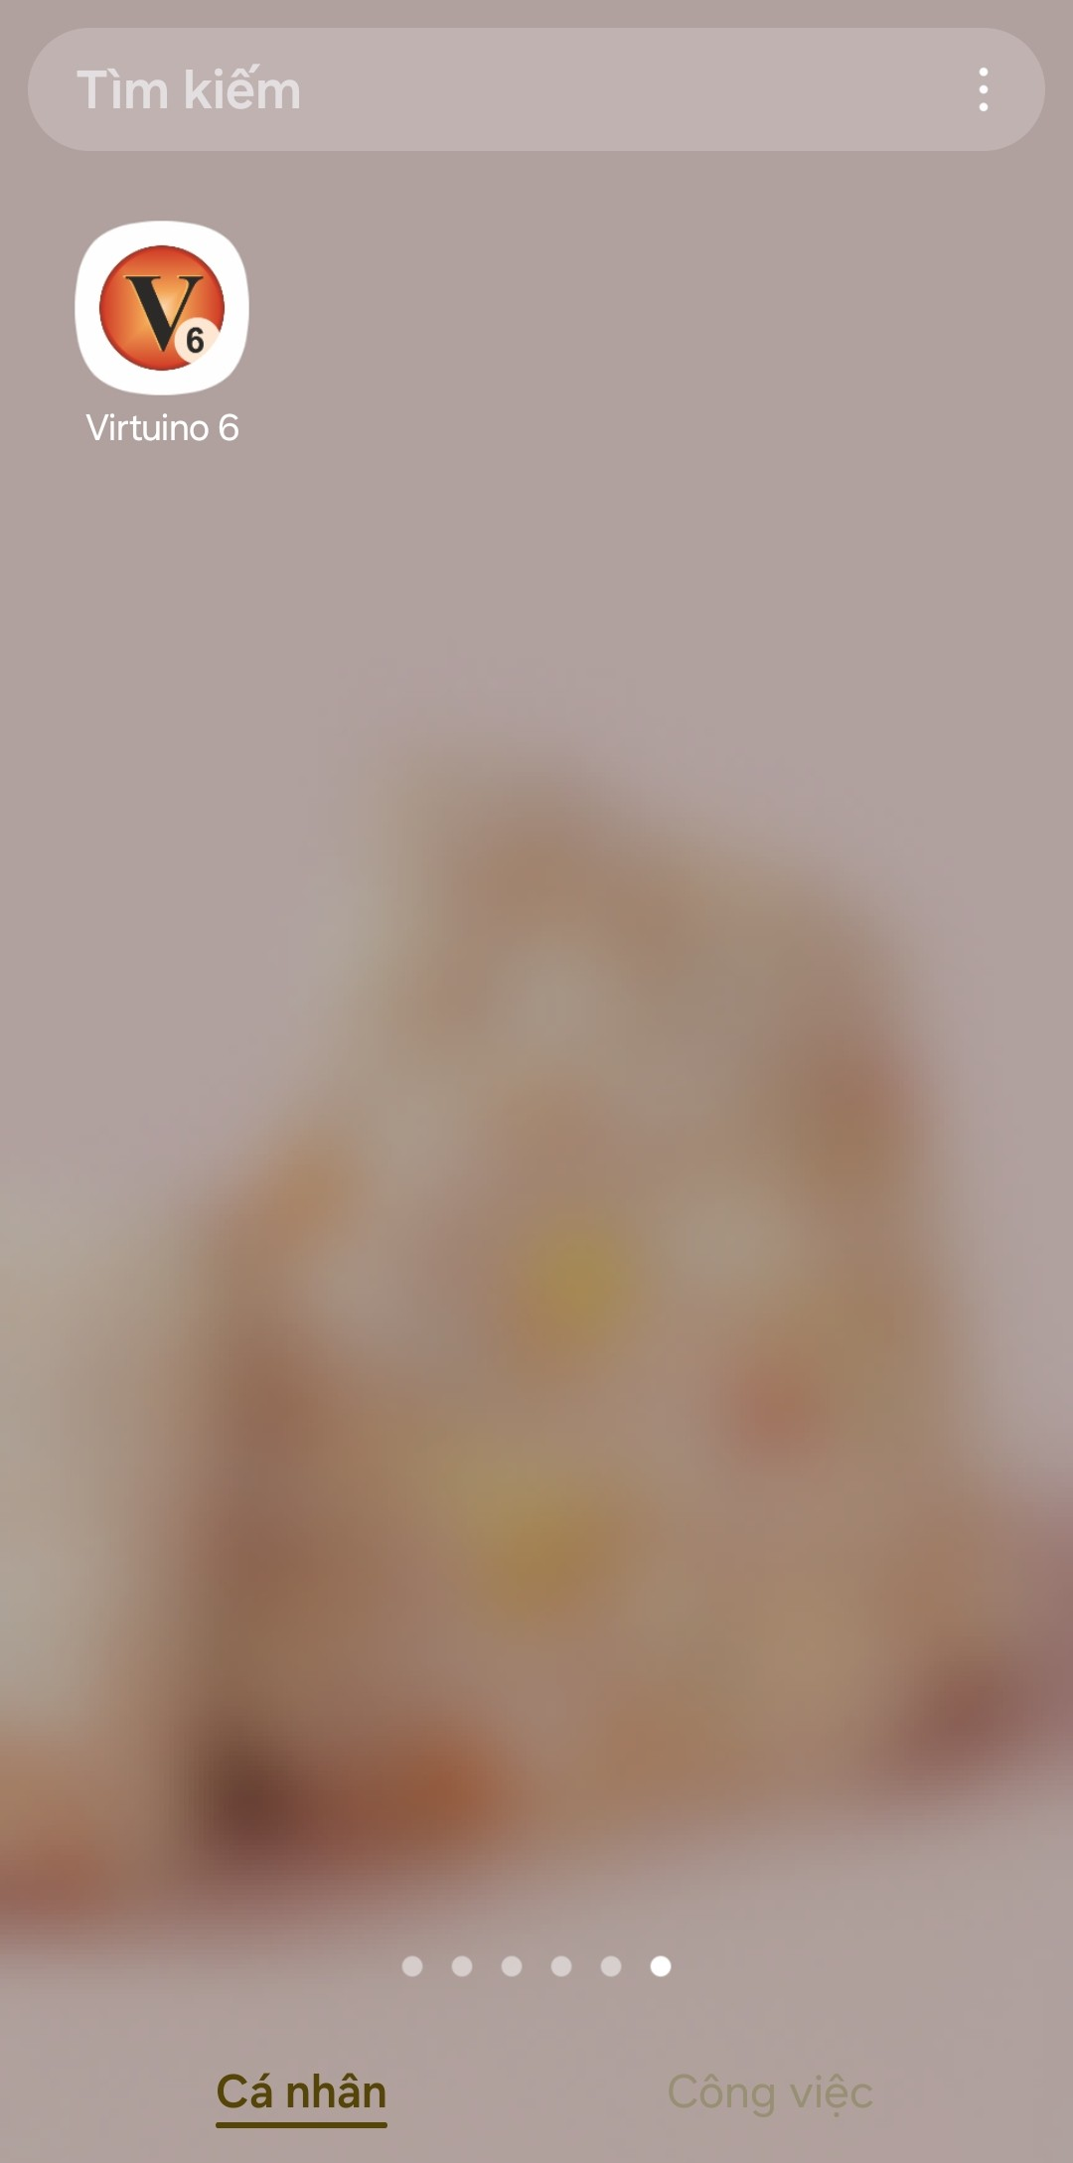 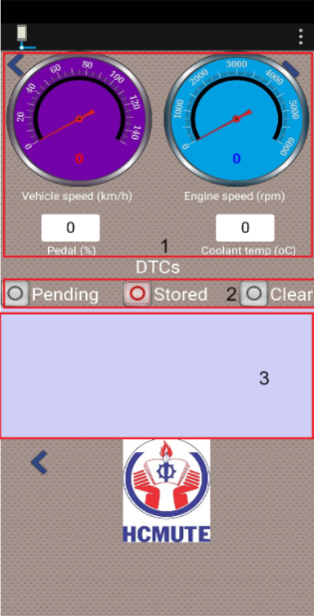

Figure 5.7: User interface

* + 1. **Principle of operation of the application**

After successfully connecting to bluetooth, 4 data: vehicle speed, engine speed, position of pedal and engine coolant temperature are always updated and displayed in zone 1 when the vehicle is operating. In area 2, the user will choose to show DTC in Stored and Pending or Clear the DTC. If the user chooses to display the DTC in Pending or Stored, the DTC data will be displayed in area 3. If the user chooses Clear, the system will delete the DTC in Stored and the data will be updated the next time the DTC is viewed.

* 1. **Algorithm flowchart**
     1. **Arduino's algorithm flow chart**
        1. **Flow chart of algorithm to get vehicle parameters**

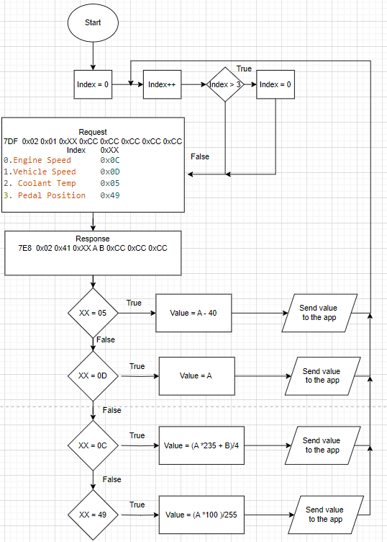

Figure 5.8: Flow chart of algorithm to get vehicle parameters

Obtaining current vehicle data is determined by sending a request signal with ID = 7DF, Mode = 0x01 and PID = 0xXX. With XX determined by the Index value: 0. Engine Speed 0x0C, 1 .Vehicle Speed 0x0D, 2. Coolant Temp 0x05, 3. Pedal Position 0x49. Index increases by 1 after each request and resets = 0 after Index > 4. Then there will be a response signal returned with ID = 7E8, Mode = 0x41 and PID = 0xXX. For each XX returned, there will be data A and B to calculate each current value of the vehicle. Then send data to the phone application for the user to see and return to continue sending requests and receive responses for further processing**.**

* + - 1. **Flow chart of algorithm to get DTC**

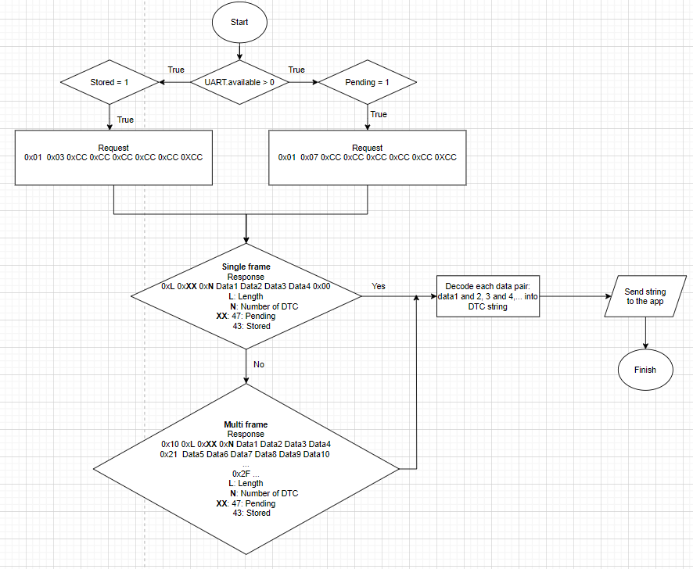

Figure 5.9: Flow chart of algorithm to get DTC

If the user chooses the mode on the application, a signal will be sent to the system. The system will compare and perform the user's desired function. If the user chooses the Pending or Stored function, the system will send a request signal 0x01 0xXX 0xCC 0xCC 0xCC 0xCC 0xCC 0xCC with XX being 03: Stored and 07: Pending. Then there will be a return signal. If the number of error codes is less than or equal to 2, a single frame will be returned, but if greater than 2, a multi frame will be returned. It will then decode each pair of data and send it to the application for the user to see.

* Format of single frame:

0xL 0xXX 0xN Data1 Data2 Data3 Data4 0x00

L: Length

N: Number of DTCs

XX: 47: Pending

43: Stored

* Format of multi frame:

0x10 0xL 0xXX 0xN Data1 Data2 Data3 Data4

0x21 Data5 Data6 Data7 Data8 Data9 Data10

...

0x2F ...

L: Length

N: Number of DTC

XX: 47: Pending

43: Stored

* + - 1. **Flow chart of algorithm to clear DTC**

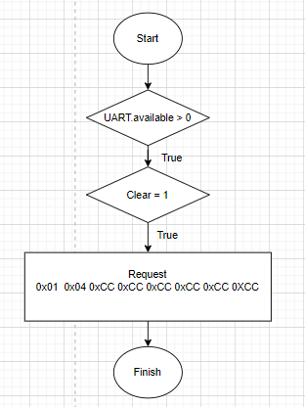

Figure 5.10: Flow chart of algorithm to clear DTC

If the user selects the mode on the application, a signal will be sent to the system. The system will compare and perform the function the user desires. If the user selects the Clear function, the system will send a request signal 0x01 0x04 0xCC 0xCC 0xCC 0xCC 0xCC 0xCC to clear the existing stored DTC.

* + 1. **Application’s algorithm flow chart**

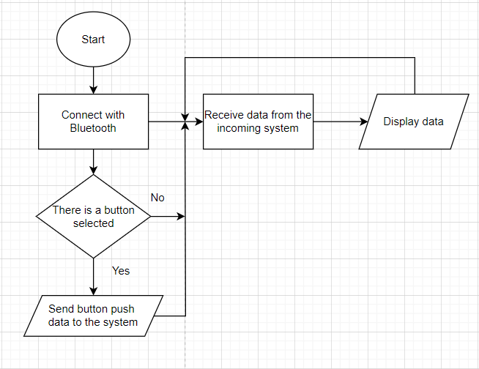

Figure 5.11: Application’s algorithm flow chart

After starting the application, we connect the application to the Bluetooth device. After successful connection, the application will continuously receive vehicle parameter data and that data will be displayed on each corresponding widget location. If any button is selected, the button signal will be sent to the system for comparison and processing. After completing processing, the system will send data to the application to display on the widget if available.

# **: TESTING ON CAR**

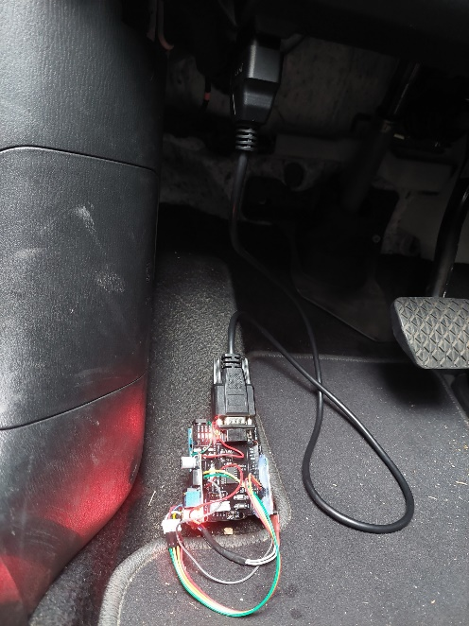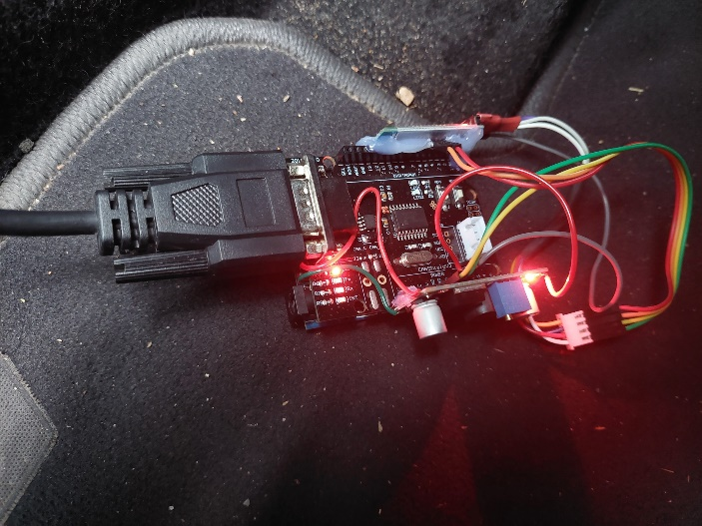After connecting the hardware to the vehicle via the OBD2 port, the system light will light up

Figure 6.1: Hardware when plugged into OBD2 port

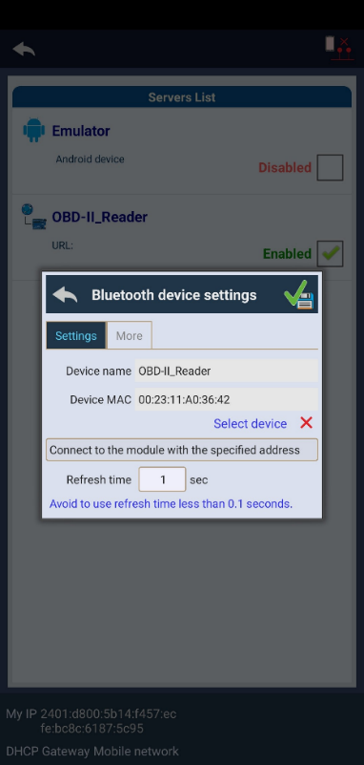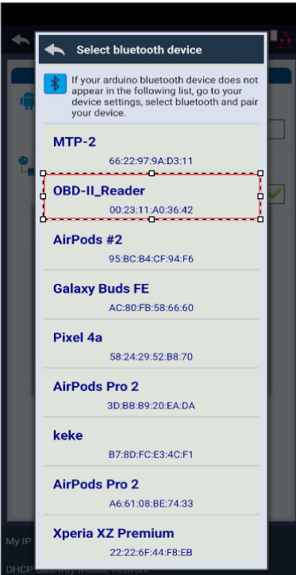Open the app, select the bluetooth y ou want to connect to and then connect.

Figure 6.2: Select bluetooth

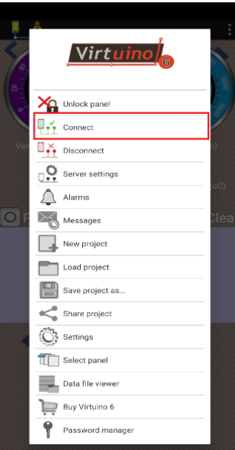

Figure 6.3: Connect with bluetooth

* 1. **Testing the vehicle's current parameter data**

After connecting to bluetooth, the car is in STOP mode so the data is not displayed.

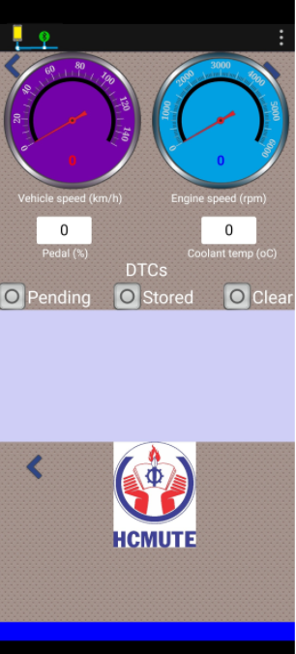

Figure 6.4: Data displayed when in STOP mode

Next, switch to the vehicle's ACC mode. Now you have pedal position and engine coolant temperature data. Because the vehicle has not started yet, the vehicle speed and engine speed do not have data.

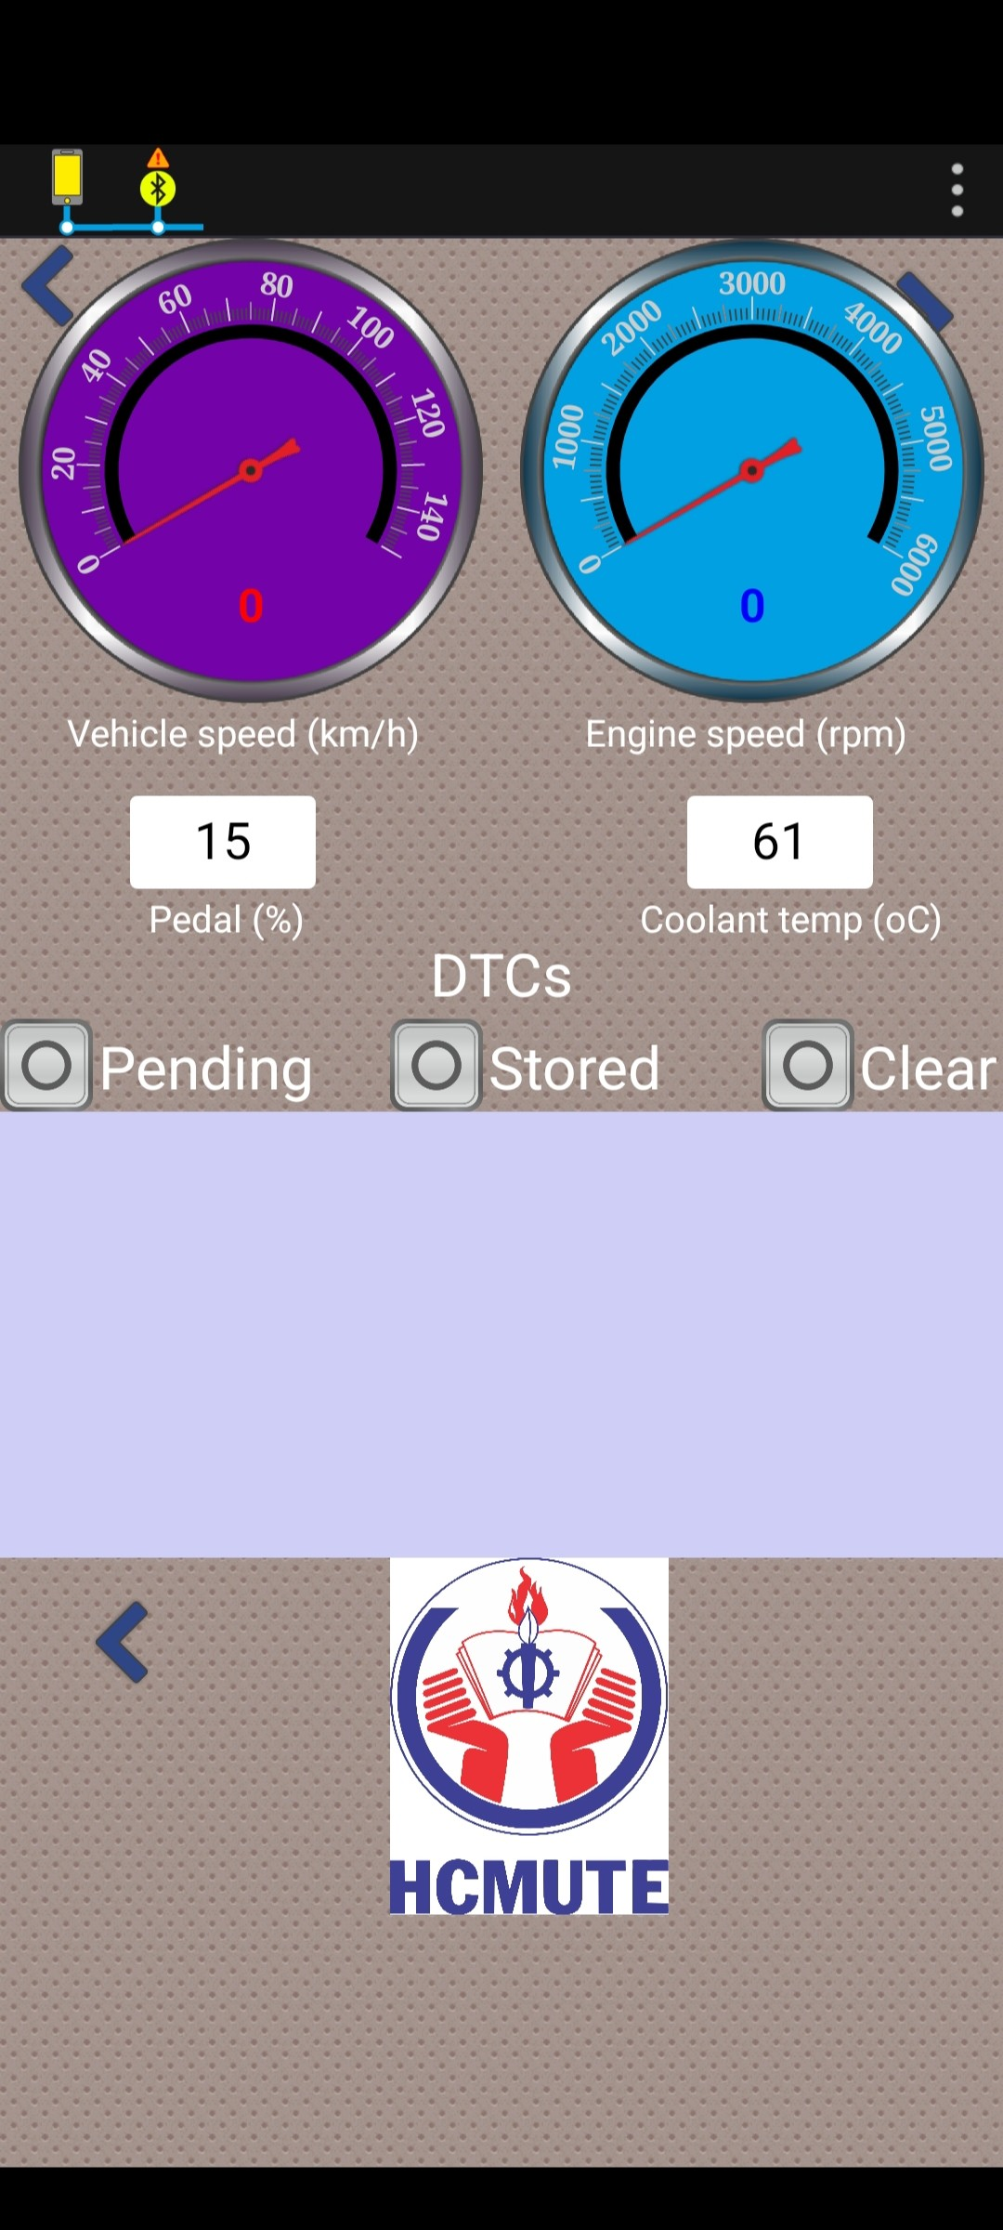

Figure 6.5: Data displayed when in ACC mode

After switching to START mode, the engine starting for ignition should have engine speed data at idle speed. After the car starts running, we receive all 4 data.

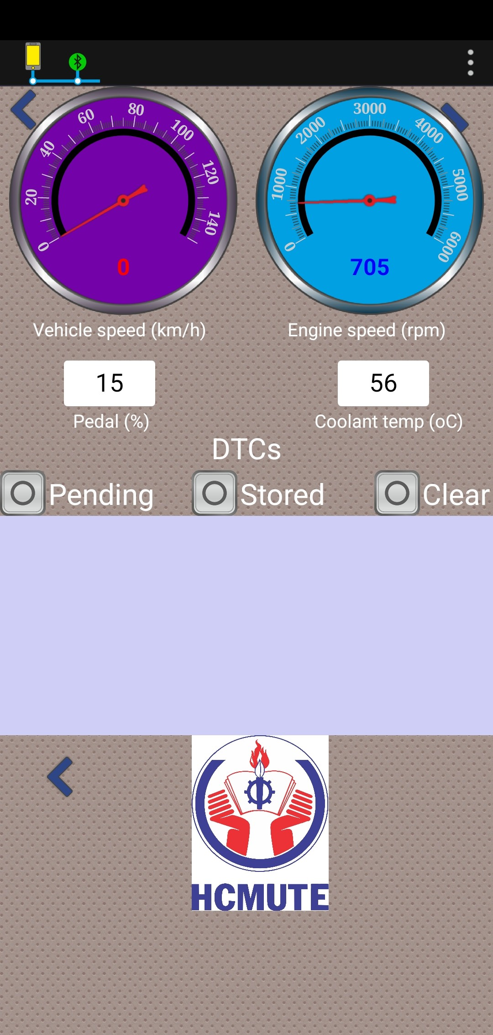

Figure 6.6: Data displayed when the vehicle is in START mode but not moving

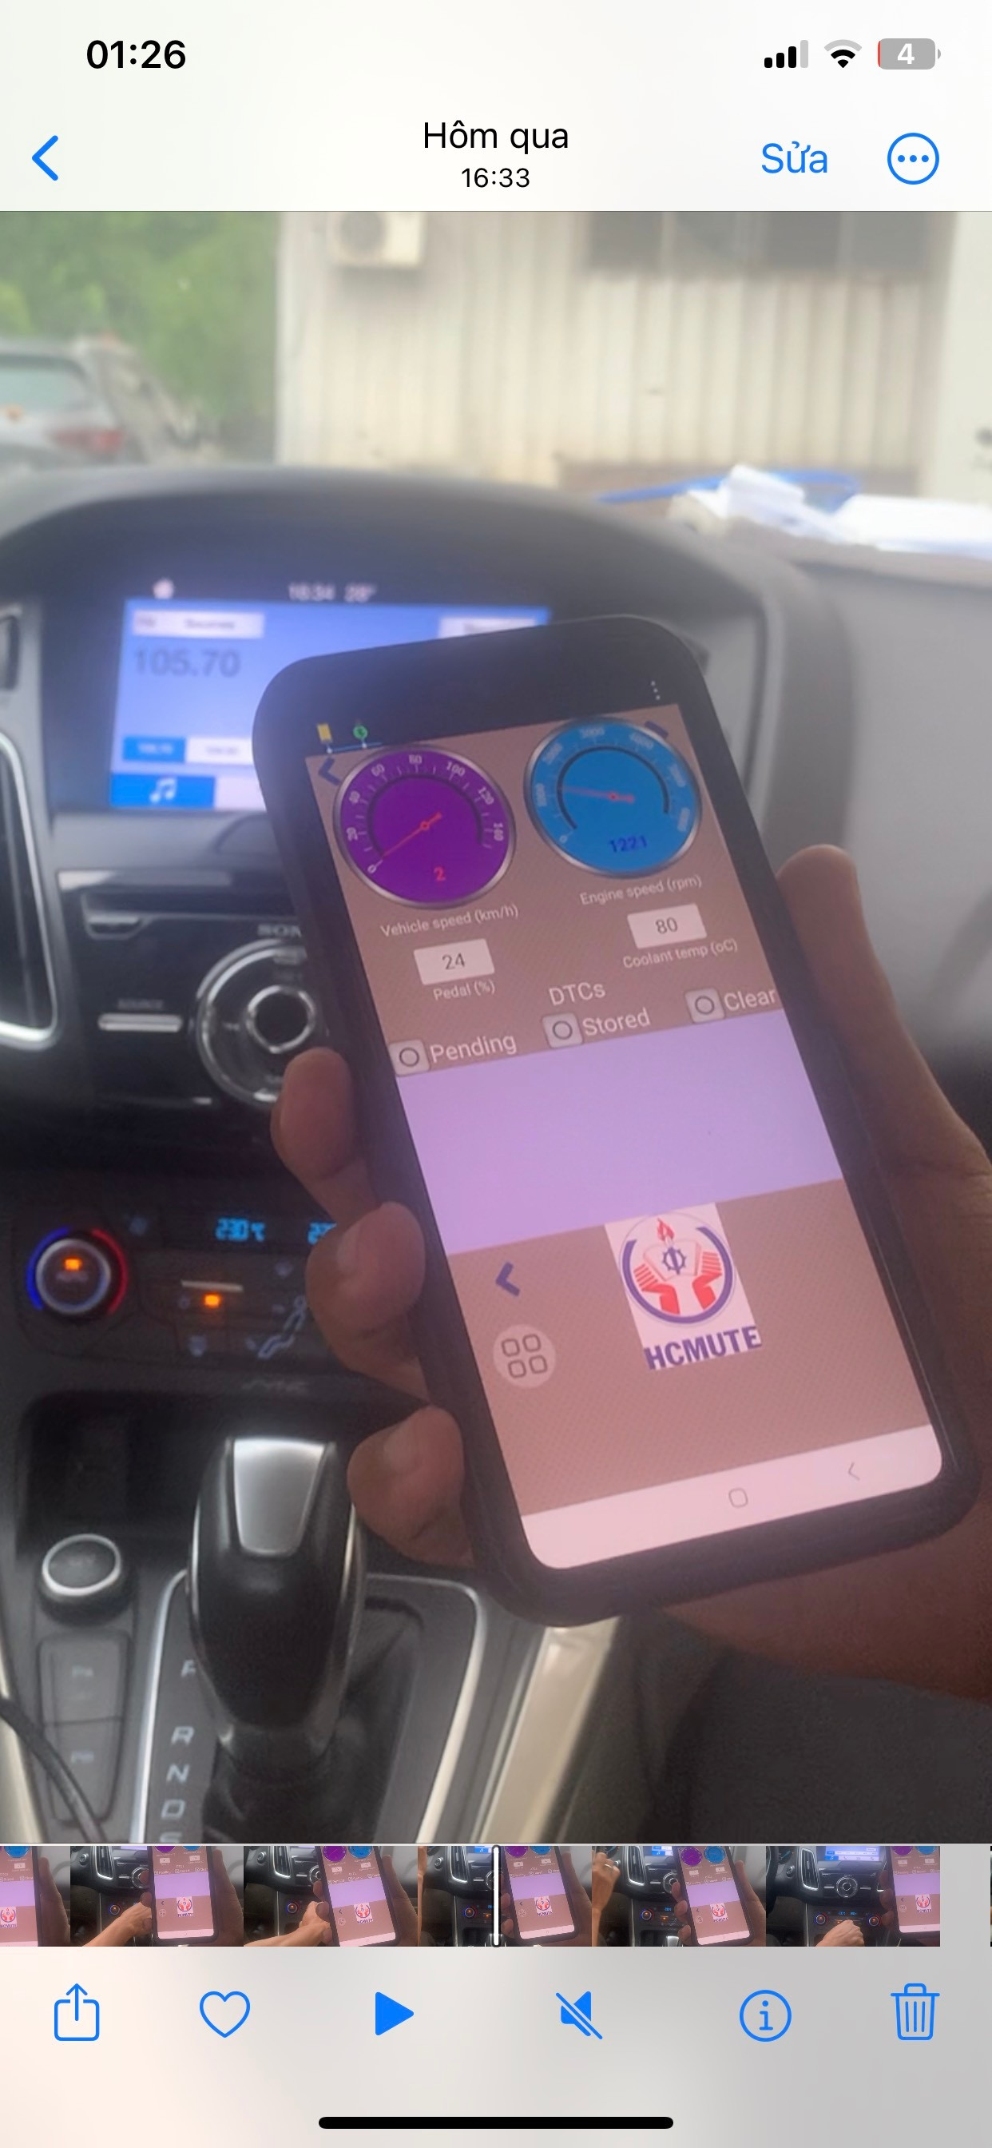

Figure 6.7: Data displayed when the vehicle moves

* 1. **Testing the vehicle's DTC**

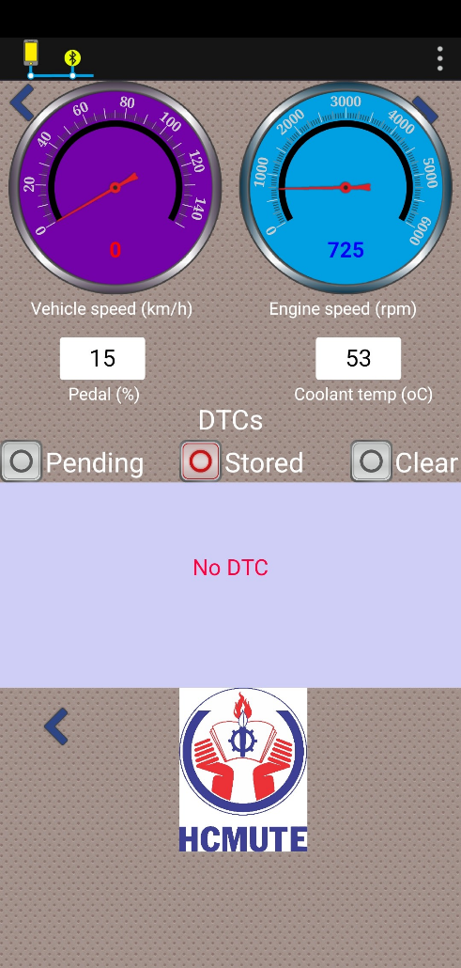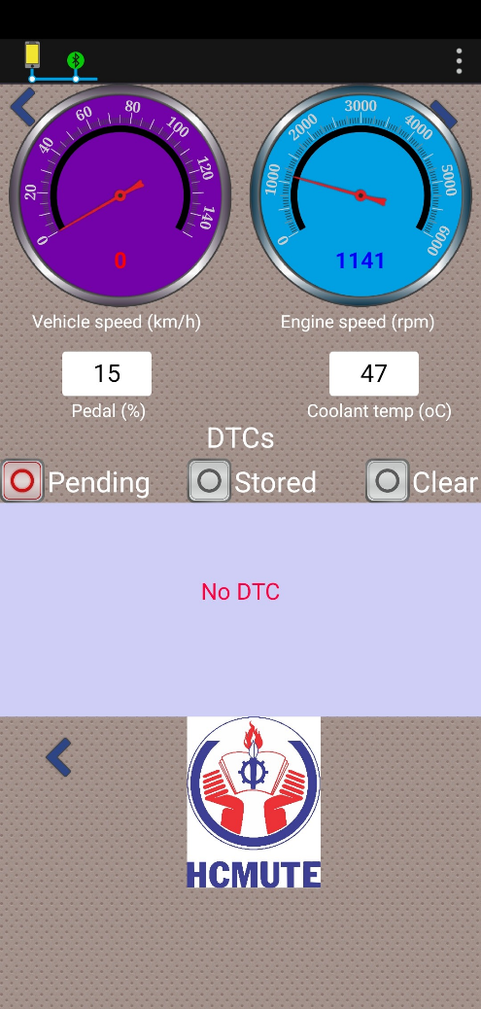To view the vehicle's DTC, the user selects two modes: Pending or Stored. When the vehicle is in normal condition, DTCs will not appear.

Figure 6.8: No DTC when the vehicle is in normal condition

When removing the Intake Air Temperature sensor, the DTC will appear on the application.

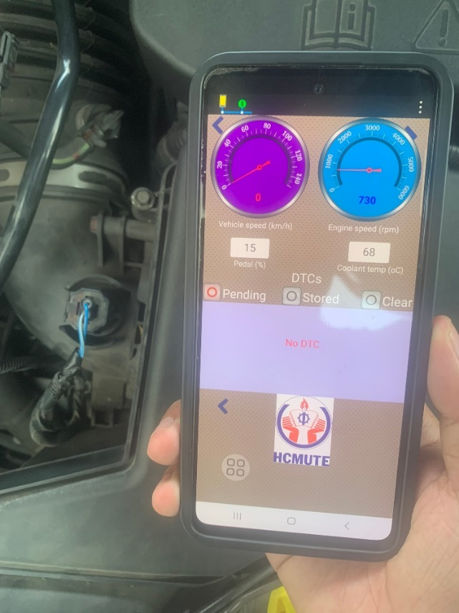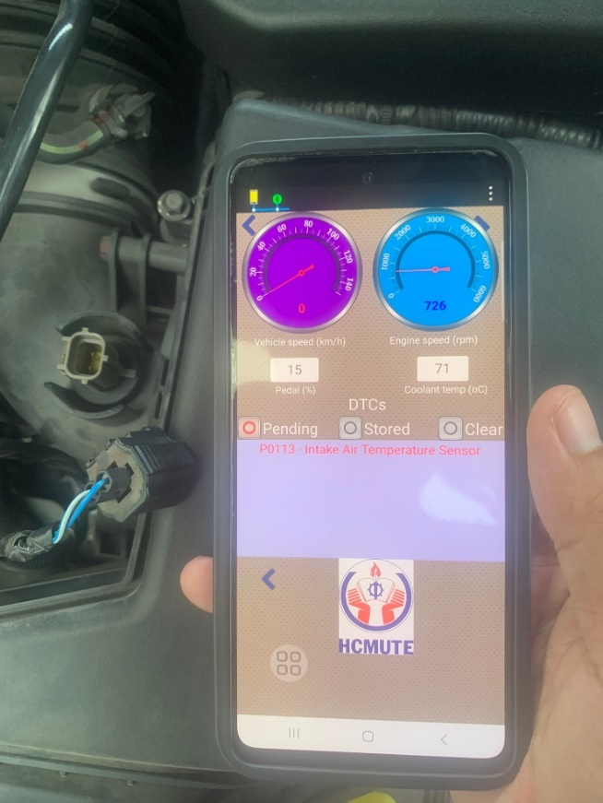When you plug the sensor back in and select Clear mode, the DTC will be cleared and the system returns to normal.



Figure 6.9: DTC appears when the system has a problem

S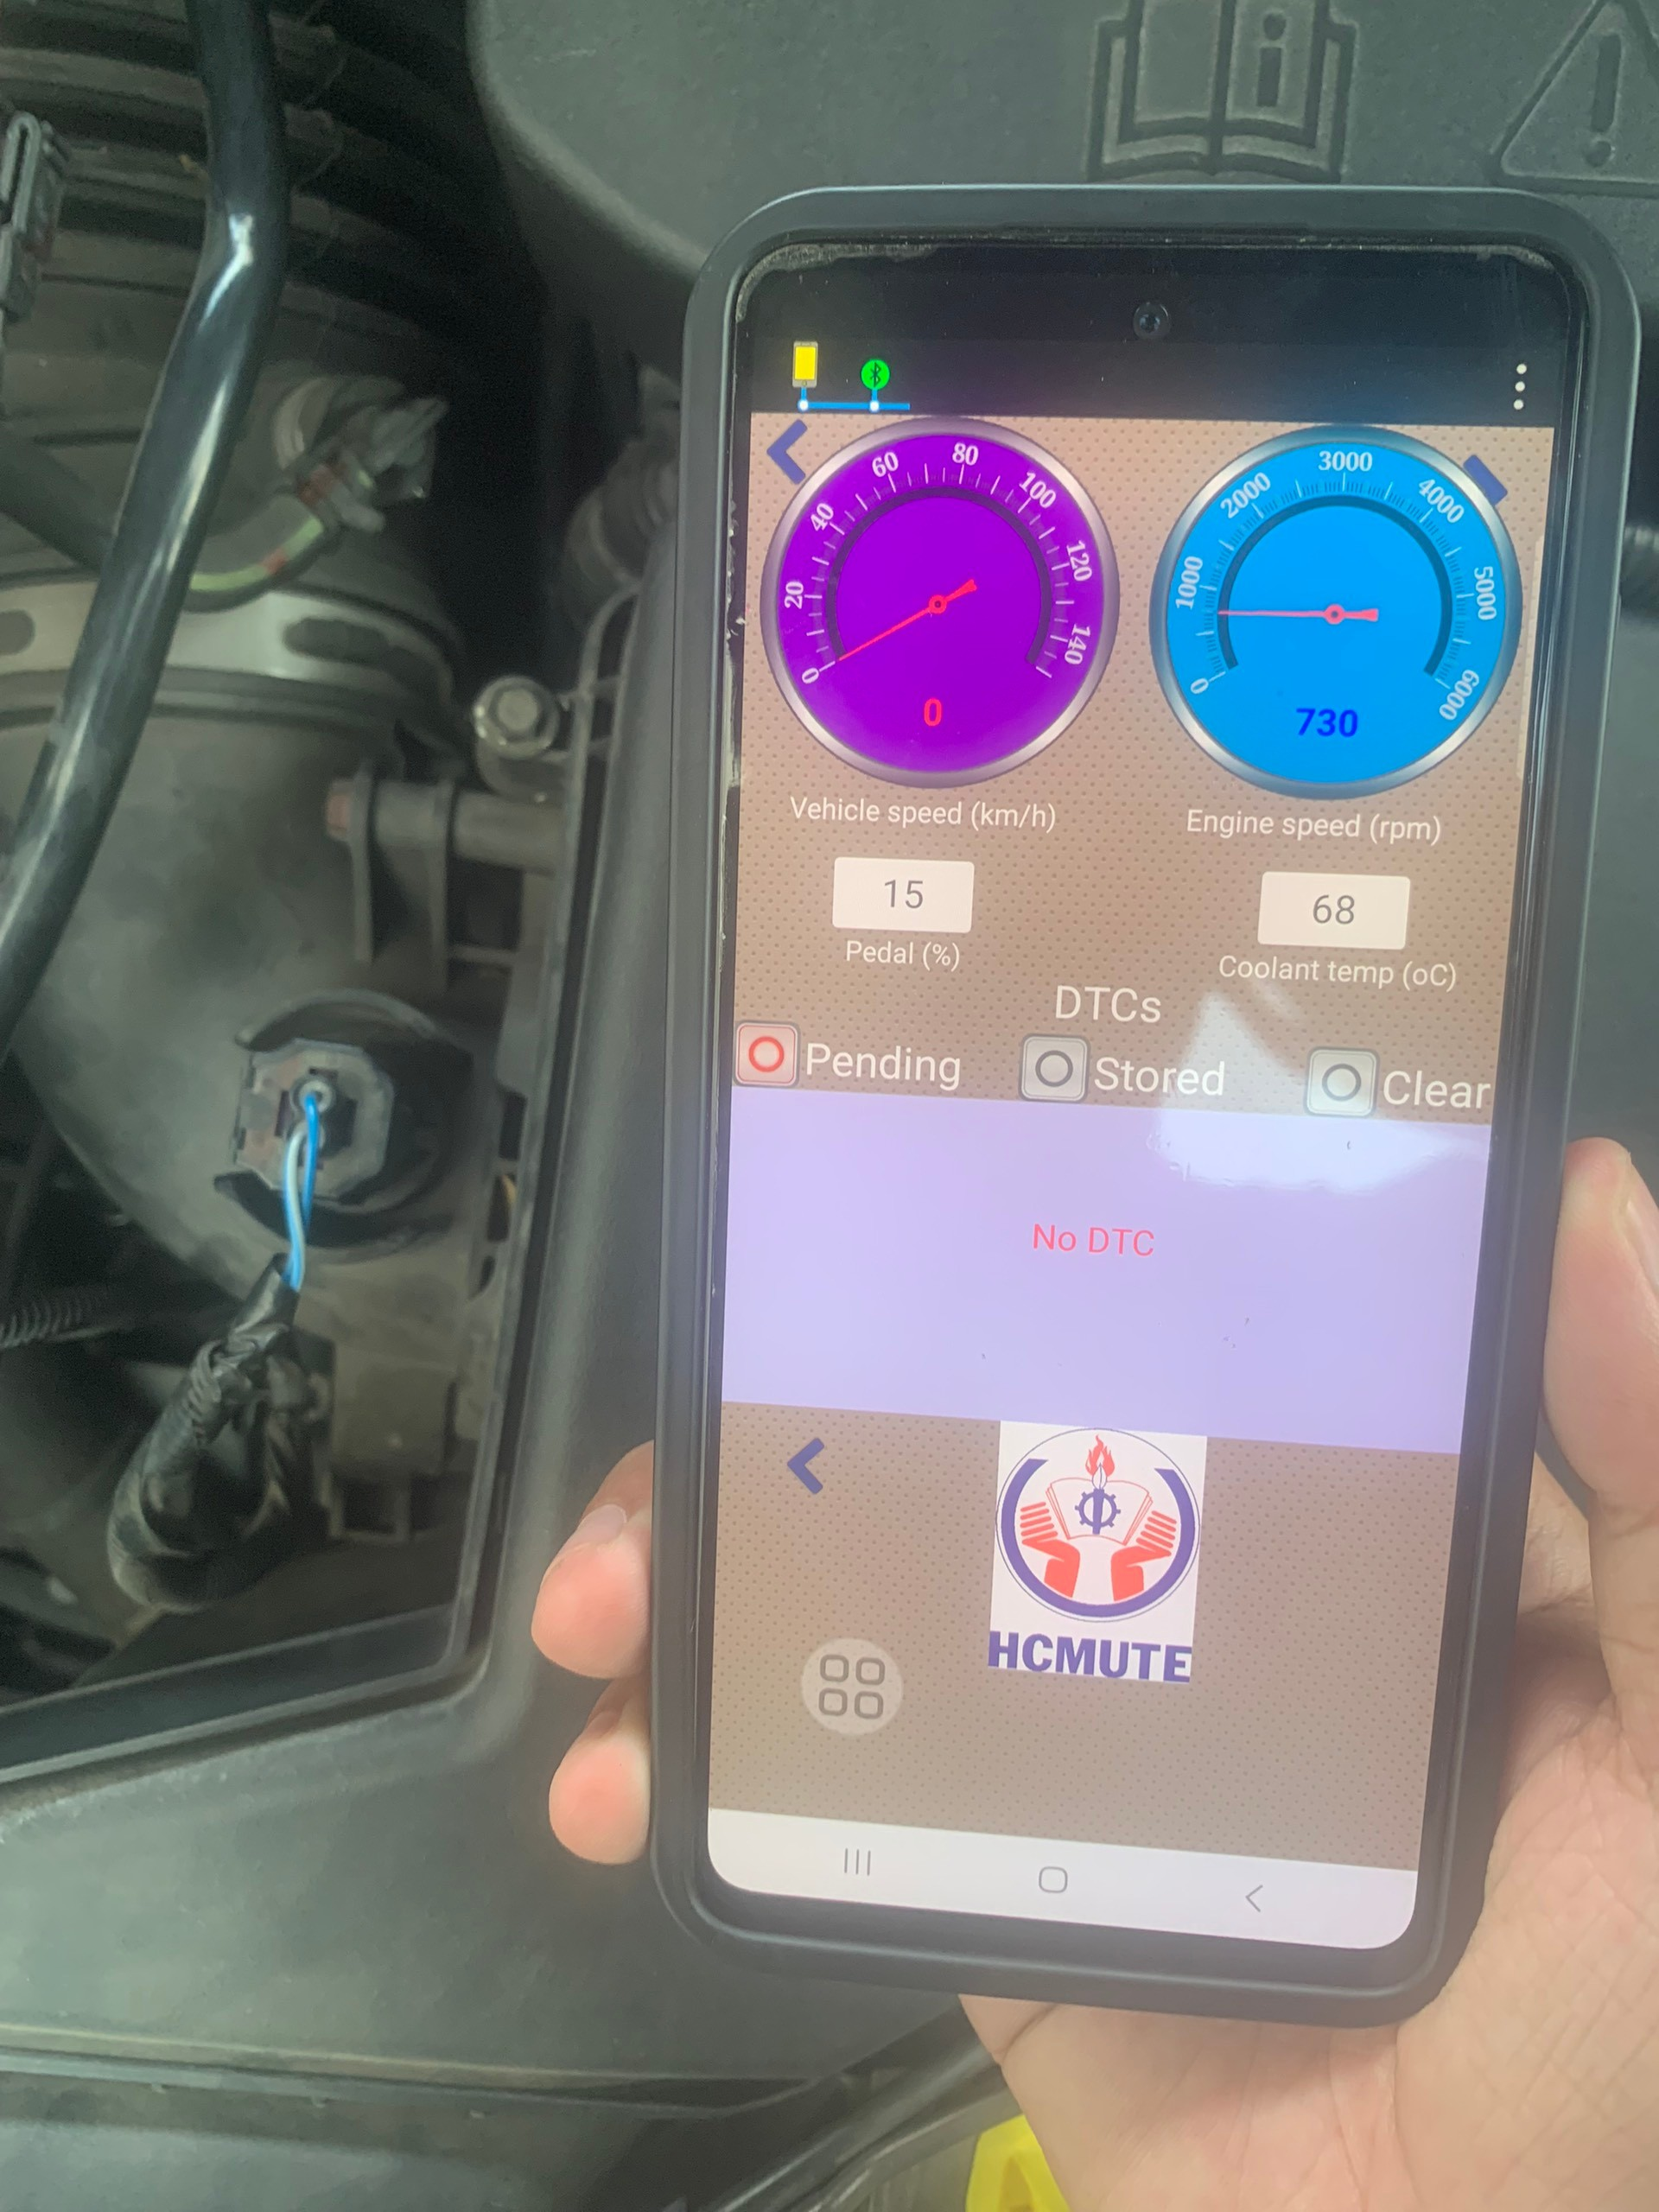



Figure 6.10: DTC data after clearing

7. **: CONCLUSION AND RECOMMENDATIONS**
   1. **Conclusion**

The study successfully achieved its mission of designing and implementing a system for displaying vehicle parameters on smartphones through the OBD-II interface. By conducting a thorough research and analysis of the CAN communication protocol, we understanding of its message structures, arbitration IDs, data formats, and error handling mechanisms was established. This knowledge paved the way for simulating CAN signal transmission and reception, ensuring accurate and reliable data transfer between the OBD-II adapter and the smartphone.

A detailed algorithm diagram was developed to effectively decode the received CAN messages, extracting relevant vehicle parameters while accounting for message filtering, data parsing, unit conversions, and error detection. This algorithm served as the foundation for developing a dedicated reading device capable of interfacing with the vehicle's OBD-II port and transmitting data wirelessly via Bluetooth.

Furthermore, a user-friendly smartphone application was created to receive, interpret, and visualize the transmitted vehicle parameters in a clear and intuitive manner. The seamless integration of hardware and software components resulted in a functional system that empowers drivers with real-time access to crucial vehicle information, enhancing their driving experience and promoting informed decision-making regarding vehicle maintenance and performance optimization.

By accomplishing all the outlined tasks, this study successfully bridges the gap between vehicle diagnostics and mobile technology, providing a convenient and accessible solution for drivers to monitor their vehicles' health and status. The developed system demonstrates the potential of OBD-II as a valuable resource for both individual drivers and automotive professionals, paving the way for further innovation and advancement in the field of vehicle telematics.

* 1. **Limit**

Although our project has been completed, it still has many limitations:

* Compatibility: Our system only works on new vehicles equipped with an OBD2 port. As for mobile phones, our application can only be installed on the Android operating system.
* Data availability: Different vehicle manufacturers may require specific adjustments or limit the range of accessible parameters. Especially for DTCs, due to memory limitations, we cannot clearly state all DTC names, so a few common DTCs will have names, the rest will only have DTCs.
* Distance: Because it is a bluetooth connection, the range will be short (< 10m)
* Interface: Because we do not specialize in software, the application is still rudimentary and not beautiful.
* Data delay: Due to the quality of the USB-II adapter and the vehicle's communication protocols, there is a large delay between the actual value and the data displayed on the smartphone.
  1. **Recommendations**

The thesis was carried out with the initial goals set out which were to design and manufacture the system to display vehicle parameter on smartphones device.

However, in the coming time there are still some issues that need to be improved and continued to be researched such as:

* Gradual expansion: Shows additional parameters such as battery voltage, intake air temperature, throttle position and oxygen sensor readings. Prioritize parameters based on user feedback and needs.
* User-Friendly Interface Design:
  + Intuitive Navigation: Design mobile apps with clear and easy-to-navigate interfaces. Use familiar icons, menus, and visual elements to ensure users can quickly access desired information.
  + Customizable display: Allows users to personalize the layout, choose which parameters to display prominently, and customize the units of measurement (for example, metric or imperial).
* Background data collection: Implement mechanisms to collect and store data even when the application is inactive. This allows users to review historical data and track trends over time.
* Cloud Integration: Explore the possibility of integrating with cloud services for data storage, analysis, and remote access to vehicle information.
* Efficient Data Streaming: Optimize the data transmission process to ensure real-time updates on the smartphone display. Utilize efficient protocols and compression techniques to minimize latency and reduce data usage.
* Diagnostic Trouble Code (DTC) Interpretation: Integrate a feature to interpret DTCs and provide plain-language explanations along with potential solutions or repair recommendations.

# **REFERENCE**

[1] Nguyen, D.T. and Kajita, Y. (2018) ‘Traffic congestion and impact on the environment in Vietnam: Development of public transport system - experience from actual operation of bus in Hanoi’, Journal of Civil &amp; Environmental Engineering.

[2] Farkash, G. (2024) The Complete Guide to car sharing: Benefits, types, and how it work, CarInsurent. Available at: https://carinsurent.com/car-rental/the-complete-guide-to-car-sharing-benefits-types-and-how-it-wor/ (Accessed: 10 March 2024).

[3] Teodorescu, C., Durnoi, A., & Vargas, V. (2023). The rise of the mobile internet: Tracing the evolution of portable devices. Proceedings of the International Conference on Business Excellence, 17, 1645-1654. https://doi.org/10.2478/picbe-2023-0147

[4] Olga Romanovskaya, Copywriter (2023) 8 best car sharing mobile apps: Market overview, Mobindustry. Available at: https://www.mobindustry.net/blog/top-8-carsharing-mobile-apps/ (Accessed: 10 March 2024).

[5] OBD-II Pids (2024) Wikipedia. Available at: https://en.wikipedia.org/wiki/OBD-II_PIDs (Accessed: 10 March 2024).

[6] CSS Electronics (2021) Can bus explained - a simple intro [2023], CSS Electronics. Available at: https://www.csselectronics.com/pages/can-bus-simple-intro-tutorial (Accessed: 10 March 2024).

# **APPENDICES**

**SYSTEM CONTROL PROGRAM**

#include <SPI.h>

#include <stdlib.h>

#include <string.h>

#include <Arduino.h>

#include "mcp2515_can.h"

#define CAN_2515

#include <SoftwareSerial.h>

SoftwareSerial espSerial = SoftwareSerial(4,5);

#include "VirtuinoCM.h"

VirtuinoCM virtuino;

#define V_memory_count 7

float V[V_memory_count];

boolean debug = true;

float V1_lastValue = 0;

int counterDemo = 0;

float V_old[3];

String empty_String = "   ";

String fullString[6] = {"P0113 - IAT",

                        "P0222 - TPS",

                        "P0123 - TPS",

                        "P0201 - INJ",

                        "P0351 - IGN",

                        "P0400 - EGR"};

String codeString[6] = {"P0113",

                        "P0222",

                        "P0123",

                        "P0201",

                        "P0351",

                        "P0400"};

const int SPI_CS_PIN = 10;

const int CAN_INT_PIN = 2;

mcp2515_can CAN_bus(SPI_CS_PIN);

#define EngineSpeedPID        0x0C

#define VehicleSpeedPID       0x0D

#define CoolantTempPID        0x05

#define PedalPositionPID      0x49

#define nodeID                0x7DF

uint8_t data_query[8] = {0x02, 0x01, 0x0C, 0xCC, 0xCC, 0xCC, 0xCC, 0xCC};

uint8_t query_PID_list[] = {EngineSpeedPID, VehicleSpeedPID, CoolantTempPID, PedalPositionPID};

uint8_t query_pos = 0, data_len, receive_data_value[8];

uint8_t data_readStored_DTCs[8] = {0x01, 0x03, 0x00, 0x00, 0x00, 0x00, 0x00, 0x00};

uint8_t data_clear_DTCs[8] = {0x01, 0x04, 0x00, 0x00, 0x00, 0x00, 0x00, 0x00};

uint8_t data_readPending_DTCs[8] = {0x01, 0x07, 0x00, 0x00, 0x00, 0x00, 0x00, 0x00};

uint32_t old_time, now_time, receive_id;

uint8_t CoolantTemp, VehicleSpeed;

float Pedal, EngineSpeed;

char read_buf;

uint8_t numOfDTCs, temp_decode;

uint8_t dataDecodeDTCsBuf[20];

bool FulldataDecodeDTCsBuf = false;

char DTCs[16][5];

String sDTCs[16];

void set_mask_filter()

{

  CAN_bus.init_Mask(0, 0, 0x7FC);

  CAN_bus.init_Mask(1, 0, 0x7FC);

  CAN_bus.init_Filt(0, 0, 0x7E8);

  CAN_bus.init_Filt(1, 0, 0x7E8);

  CAN_bus.init_Filt(2, 0, 0x7E8);

  CAN_bus.init_Filt(3, 0, 0x7E8);

  CAN_bus.init_Filt(4, 0, 0x7E8);

  CAN_bus.init_Filt(5, 0, 0x7E8);

}

void Query(uint8_t PID)

{

  data_query[2] = PID;

  CAN_bus.sendMsgBuf(nodeID, 0, 8, data_query);

}

void ReadStoredDTCs()

{

  Serial.println("Read stored DTCs.");

  CAN_bus.sendMsgBuf(nodeID, 0, 8, data_readStored_DTCs);

}

void ClearDTCs()

{

  Serial.println("Clear DTCs.");

  CAN_bus.sendMsgBuf(nodeID, 0, 8, data_clear_DTCs);

}

void decode_DTCs()

{

  for (uint8_t j = 0; j < numOfDTCs; j++)

  {

    switch (dataDecodeDTCsBuf[j*2] >> 6)

    {

      case 0:  DTCs[j][0] = 'P';

              break;

      case 1:  DTCs[j][0] = 'C';

              break;

      case 2:  DTCs[j][0] = 'B';

              break;

      case 3:  DTCs[j][0] = 'U';

              break;

    }

    DTCs[j][1] = ((dataDecodeDTCsBuf[j*2]&0b00111111) >> 4) + 48;

    temp_decode = dataDecodeDTCsBuf[j*2]&0b00001111;

    if (temp_decode < 10)

      DTCs[j][2] = temp_decode + 48;

    else

      DTCs[j][2] = temp_decode + 55;

    temp_decode = dataDecodeDTCsBuf[j*2 + 1] >> 4;

    if (temp_decode < 10)

      DTCs[j][3] = temp_decode + 48;

    else

      DTCs[j][3] = temp_decode + 55;

    temp_decode = dataDecodeDTCsBuf[j*2 + 1]&0b00001111;

    if (temp_decode < 10)

      DTCs[j][4] = temp_decode + 48;

    else

      DTCs[j][4] = temp_decode + 55;

  }

  printDTCs();

  numOfDTCs = 0;

  FulldataDecodeDTCsBuf = false;

}

void printDTCs()

{

  if (numOfDTCs == 0)

  {

    Serial.println("No DTCs.");

    sDTCs[0] = empty_String;

    sDTCs[1] = empty_String;

    sDTCs[2] = "No DTC";

    sDTCs[3] = empty_String;

    sDTCs[4] = empty_String;

    sDTCs[5] = empty_String;

  }

  else

  {

    Serial.print("The engine has ");

    Serial.print(numOfDTCs);

    Serial.println(" error codes:");

    for (uint8_t j = 0; j < numOfDTCs; j++)

    {

      sDTCs[j] = "";

      for (uint8_t i = 0; i < 5; i++)

      {

        sDTCs[j].concat(DTCs[j][i]);

      }

      for (uint8_t k = 0; k < 6; k++)

      {

        if (sDTCs[j] == codeString[k])

        {

          sDTCs[j] = fullString[k];

        }

      }

      Serial.println(sDTCs[j]);

    }

    if (numOfDTCs < 6)

    {

      for (uint8_t l = numOfDTCs; l < 6; l++)

        sDTCs[l] = empty_String;

    }

  }

}

void ReadPendingDTCs()

{

  Serial.println("Read pending DTCs.");

  CAN_bus.sendMsgBuf(nodeID, 0, 8, data_readPending_DTCs);

}

void setup()

{

  pinMode(13, OUTPUT);

  if (debug)

  {

    Serial.begin(115200);

    while (!Serial) continue;

  }

  espSerial.begin(115200);

  espSerial.setTimeout(50);

  virtuino.begin(onReceived, onRequested, 511);

 while (CAN_OK != CAN_bus.begin(CAN_500KBPS))

 {

   Serial.println("CAN init fail, retry...");

   delay(100);

 }

  Serial.println("CAN init ok!");

  set_mask_filter();

}

void loop()

{

  virtuinoRun();

  now_time = millis();

  if ((now_time - old_time) >= 100)

  {

    old_time = now_time;

    digitalWrite(13, !digitalRead(13));

    Query(query_PID_list[query_pos]);

    query_pos = (++query_pos)%4;

  }

  if (CAN_MSGAVAIL == CAN_bus.checkReceive())

  {

    receive_id = CAN_bus.getCanId();

    CAN_bus.readMsgBuf(&data_len, receive_data_value);

//    Serial.print(receive_id, HEX);

//    for (uint8_t i = 0; i < 8; i++)

//    {

//      Serial.print('\t');

//      Serial.print(receive_data_value[i], HEX);

//    }

//    Serial.println();

    if ((receive_data_value[1]) == 0x41)

    {

      switch (receive_data_value[2])

      {

        case 0x05:  CoolantTemp = receive_data_value[3] - 40;

//                    Serial.print("CoolantTemp: ");

//                    Serial.println(CoolantTemp);

                      V[3] = CoolantTemp;

                    break;

        case 0x0C:  EngineSpeed = (float)(receive_data_value[3]*235 + receive_data_value[4])/4.0;

//                    Serial.print("EngineSpeed: ");

//                    Serial.println(EngineSpeed);

                      V[1] = EngineSpeed;

                    break;

        case 0x0D:  VehicleSpeed = receive_data_value[3];

//                    Serial.print("VehicleSpeed: ");

//                    Serial.println(VehicleSpeed);

                      V[0] = VehicleSpeed;

                    break;

        case 0x5A:  Pedal = (float)receive_data_value[3]*100/255.0;

//                    Serial.print("Pedal: ");

//                    Serial.println(Pedal);

                      V[2] = Pedal;

                    break;

      }

    }

    if ((receive_data_value[1] == 0x43)||(receive_data_value[1] == 0x47))

    {

      if (receive_data_value[2]*2 == (receive_data_value[0] - 2))

      {

        numOfDTCs = receive_data_value[2];

        dataDecodeDTCsBuf[0] = receive_data_value[3];

        dataDecodeDTCsBuf[1] = receive_data_value[4];

        dataDecodeDTCsBuf[2] = receive_data_value[5];

        dataDecodeDTCsBuf[3] = receive_data_value[6];

        FulldataDecodeDTCsBuf = true;

      }

    }

    if (receive_data_value[0] == 0x10)

    {

      if ((receive_data_value[2] == 0x43)||(receive_data_value[2] == 0x47))

      {

        if (receive_data_value[3]*2 == (receive_data_value[1] - 2))

        {

          numOfDTCs = receive_data_value[3];

          dataDecodeDTCsBuf[0] = receive_data_value[4];

          dataDecodeDTCsBuf[1] = receive_data_value[5];

          dataDecodeDTCsBuf[2] = receive_data_value[6];

          dataDecodeDTCsBuf[3] = receive_data_value[7];

        }

      }

    }

    if (receive_data_value[0] == 0x21)

    {

      for (uint8_t j = 1; j < 8; j++)

      {

        dataDecodeDTCsBuf[3 + j] = receive_data_value[j];

        if ((3 + j) == (numOfDTCs*2 - 1))

        {

          FulldataDecodeDTCsBuf = true;

          break;

        }

      }

    }

    if (receive_data_value[0] == 0x22)

    {

      for (uint8_t j = 1; j < 8; j++)

      {

        dataDecodeDTCsBuf[10 + j] = receive_data_value[j];

        if ((10 + j) == (numOfDTCs*2 - 1))

        {

          FulldataDecodeDTCsBuf = true;

          break;

        }

      }

    }

    if (receive_data_value[0] == 0x23)

    {

      for (uint8_t j = 1; j < 8; j++)

      {

        dataDecodeDTCsBuf[17 + j] = receive_data_value[j];

        if ((17 + j) == (numOfDTCs*2 - 1))

        {

          FulldataDecodeDTCsBuf = true;

          break;

        }

      }

    }

    if (receive_data_value[0] == 0x24)

    {

      for (uint8_t j = 1; j < 8; j++)

      {

        dataDecodeDTCsBuf[24 + j] = receive_data_value[j];

        if ((24 + j) == (numOfDTCs*2 - 1))

        {

          FulldataDecodeDTCsBuf = true;

          break;

        }

      }

    }

    if (FulldataDecodeDTCsBuf)

    {

      decode_DTCs();

    }

  }

  if ((V_old[0] == 0)&&(V[4] == 1))

  {

    ReadPendingDTCs();

  }

  if ((V_old[1] == 0)&&(V[5] == 1))

  {

    ReadStoredDTCs();

  }

  if ((V_old[2] == 0)&&(V[6] == 1))

    ClearDTCs();

  V_old[0] = V[4];

  V_old[1] = V[5];

  V_old[2] = V[6];

  if ((V[4] == 0)&&(V[5] == 0))

  {

    sDTCs[0] = empty_String;

    sDTCs[1] = empty_String;

    sDTCs[2] = empty_String;

    sDTCs[3] = empty_String;

    sDTCs[4] = empty_String;

    sDTCs[5] = empty_String;

  }

  if (Serial.available())

  {

    read_buf = Serial.read();

    if (read_buf == '3')

      ReadStoredDTCs();

    if (read_buf == '4')

      ClearDTCs();

    if (read_buf == '7')

      ReadPendingDTCs();

  }

}

void onReceived(char variableType, uint8_t variableIndex, String valueAsText)

{

  if (variableType == 'V')

  {

    float value = valueAsText.toFloat();

    if (variableIndex < V_memory_count)

      V[variableIndex] = value;

  }

}

String onRequested(char variableType, uint8_t variableIndex)

{

  if (variableType == 'V')

  {

    if (variableIndex < V_memory_count)

      return  String(V[variableIndex]);

    else if (variableIndex == 7)

      return sDTCs[0];

    else if (variableIndex == 8)

      return sDTCs[1];

    else if (variableIndex == 9)

      return sDTCs[2];

    else if (variableIndex == 10)

      return sDTCs[3];

    else if (variableIndex == 11)

      return sDTCs[4];

    else if (variableIndex == 12)

      return sDTCs[5];

  }

  return "";

}

void virtuinoRun()

{

  while (espSerial.available())

  {

    char tempChar = espSerial.read();

    if (tempChar == CM_START_CHAR)

    {

      virtuino.readBuffer = CM_START_CHAR;

      virtuino.readBuffer += espSerial.readStringUntil(CM_END_CHAR);

      virtuino.readBuffer += CM_END_CHAR;

      String* response = virtuino.getResponse();

      espSerial.print(*response);

      break;

     }

  }

}

void vDelay(int delayInMillis)

{

  long t = millis() + delayInMillis;

  while (millis() < t)

    virtuinoRun();

}